Improving IoT Security through Advanced Prestige-based Connection Tracking

Tusha, Quantum University Research Center, Quantum University, Email: tusha@quantumeducation.in, Orcid Id: 0009-0001-5904-2139

Vaibhav Kaushik, Centre of Research Impact and Outcome, Chitkara University, Rajpura- 140417, Punjab, India. vaibhav.kaushik.orp@chitkara.edu.in https://orcid.org/0009-0001-0234-3205

Lalit Khanna, Chitkara Centre for Research and Development, Chitkara University, Himachal Pradesh-174103 India. lalit.khanna.orp@chitkara.edu.in https://orcid.org/0009-0004-6832-2206

M.VIGENESH, Department of Computer Science Engineering, Karpagam Academy of Higher Education, Coimbatore- 641021. Email Id: vigenesh.murugesan@kahedu.edu.in

K.SRIRAM KUMAR, Department of Information Technology, Karpagam Institute of Technology, Coimbatore- 641105, Email Id: sriramkumar.pla@karpagamtech.ac.in

Dr.Supriya Rai, Associate Professor, Department of Management, School of Mangement - UG, JAIN (Deemed to be University), Bangalore, Karnataka, India, Email Id- supriya@cms.ac.in
Abstract--- IoT security needs to be strengthened as smart homes are more connected and prone to complex cyberattacks. One innovative approach to identify and lower negative behavior in IoT networks is prestige-based connection monitoring. However, by having restricted scalability, poor trust assessment, and vulnerability to node impersonation or penetration, existing methods might threaten the integrity of the network. This work proposes a Blockchain-based Reputation System (BC-RS) based dynamic and transparent node trust assessment to tackle these limits in order to avoid hostile node infiltration in smart home networks. By use of distributed ledgers, the BC-RS system assures tamper-proof integrity of reputation data, computes trust ratings, and records node interactions. The proposed method monitors node behavior, finds real-time harmful activity, and prevents untrusted nodes from network connection. Experimental analysis shows that the framework enhances network security by increasing trust score accuracy by 98.2%, reducing false positives in threat detection by 39%, and improving system resilience by 97.6%. These findings confirm the effectiveness of prestige-based tracking combined with blockchain in strengthening IoT security and ensuring safer smart home environments.
Keywords--- IoT Security, Blockchain, Reputation System, Smart Home, Malicious Node Detection, Trust Evaluation.

Introduction
The IoT is changing the way to interact with the surroundings, especially in smart homes, where connected devices allow automation, convenience, and real-time monitoring [1]. From automated thermostats and light switches to surveillance cameras and voice assistants, IoT devices are increasingly a part of contemporary life [2]. As the number of connected devices increases, however, so does the surface area of potential cyber risks. Malicious parties will be able to take advantage of vulnerabilities in open IoT systems in order to illegally access, sniff out sensitive information, or even cause interruptions in vital household functionalities. It is therefore imperative that IoT networks, particularly smart homes, are secure [3]. Prestige-based connection tracking is a new way to strengthen IoT security that focuses on monitoring nodes for their trust based on behaviour and history of encounters. Unlike fixed security solutions, the dynamic model constantly reviews and recalculates the reputation of every device, thereby learning how to respond to changing threats [4]. Still, traditional trust-based systems have numerous major weaknesses. Usually opaque and non-scalable, they are easily manageable [5]. Furthermore more prone to single points of failure and maybe unable to manage the complexity of large-scale smart home configurations are centralized designs. These restrictions emphasize the necessity of a better, distributed, and creative solution for IoT security [6].
This study offers a fresh way BC-RS approaches these challenges. This method is aimed to avoid hostile node invasion in smart home networks by means of distributed ledgers to monitor and verify trust scores [7]. Every device interaction is continuously recorded on the blockchain, therefore guaranteeing auditability, transparency, and immunity to tampering [8]. The BC-RS architecture assigns dynamic reputation ratings to every node and runs constantly on watching communication behavior. Malicious or suspicious nodes lose trust value, which distances them from the network ultimately [9]. At last kicked from the network are compromised nodes [10]. Trusted nodes get more respect, and communication runs free and without dispute. It drastically lowers phishing, node impersonation, denial-of- service attacks [11]. Apart from improving the security posture of smart home IoT systems, the intended BC-RS design generates circumstances for more robust, self-sustaining, and intelligent security systems [12]. It provides a scalable approach to protect next-generation smart environments by means of distributed consensus and ongoing trust assessment [13].
Contributions:
- 2blockchain technology to monitor and confirm the trustworthiness of Internet of Things (IoT) nodes in real-time [14]. The immutable ledger allows for transparent and dynamic trust score computation and tamper-proof recording of node behaviour.
- The suggested method enhances the detection of suspicious behaviours by continuously analysing node interactions and assigning adaptive prestige scores. This proactive security model effectively isolates nodes that are not trustworthy or compromised, preventing them from causing harm to the smart home network.
- The experimental analysis shows that the proposed system improves trust score accuracy by 48% and reduces false positives in threat detection by 39%. These developments lead to higher system security standards.
The remaining of this paper is structured as follows: In section 2, the related work of IoT security is studied. In section 3, the proposed method is explained. In section 4, the result of the paper is discussed. Finally, in section 5 the paper is concluded with the future work [15].

Related Work
Traditional centralized cloud systems are facing challenges from the exponential expansion of network data, which has led to the advent of edge computing. Still, problems like unreliable data storage and a lack of confidence persist [16]. In order to improve data quality, consensus efficiency, and security in edge and Industrial IoT contexts, Blockchain Technology (BCT) in conjunction with Machine Learning Algorithms (MLA) like Support Vector Machines (SVM) provides unique solutions [17].
Deep Learning Technology (DLT): Traditional centralized cloud computing data processing is facing enormous issues and constraints due to the exponential expansion of network data. The advent of edge computing technologies allowed for the resolution of this issue. Processing certain data at the edge may also enhance the user experience by bringing a quicker response, as it is closer to the user. Current edge computing systems, however, suffer from issues including insecure data storage and a lack of mutual confidence among multiparty data. DLT remarkable properties have made it a significant tool for addressing the aforementioned issues with data storage and sharing [18].
Machine Learning Algorithm (MLA): Consensus is at the heart of blockchain technology, and the system's efficiency and steadiness are directly impacted by its speed and security [19]. Thus, to increase the security and decrease resource consumption of the edge computing blockchain system, this research begins with the consensus method. MLA, or prestige-based edge computing blockchain security consensus model, is suggested as a solution to the security issue caused by the concentration of node rights, in addition to reducing the resource consumption and improving the adaptability of traditional consensus algorithms in the edge computing environment [20].
Support Vector Machine (SVM): SVM is an all-encompassing model that uses prestige incentives and punishments. Additionally, it has a method for replacing nodes to guarantee that the consensus process is fault-tolerant. After incorporating the current consensus method, the correctness of the consensus model was validated by several sets of tests comparing performance and verifying security [21]. Applications built on the Industrial Internet of Things must adhere to stringent privacy and security regulations to prevent unauthorized access to data and ensure that connected equipment may move freely across networks [22]. A solution may be found by using blockchain technology's encryption capabilities, consensus process, and decentralized structure [23]. Nevertheless, the encryption process may be complex due to the restricted resources of IoT devices. In fact, this study proposes a novel security method based on blockchain technology to ensure the safety of data transfer between IoT devices and EC. Elastic Blockchain Security (EBC) will also use two layers of security to provide a flexible framework for mobile IoT devices. The EBC solution was implemented and tested in several settings to assess its efficacy, scalability, performance, consensus process, and encryption capabilities [24].
This work introduces Elastic Blockchain Security (EBC), a two-pronged approach of securing IoT device data flows in a scalable and fail-resistant way. Experimental findings confirm via distributed and adaptive security measures the enhancement of system efficiency, consensus correctness, and privacy in resource-constrained contexts.

Proposed Method
Cyberattacks and security concerns brought out by hostile nodes are aligning with the connection of smart homes. This paper tracks the behavior of Internet of Things (IoT) nodes using a BC-RS derived on prestige-based monitoring. By means of distributed ledgers, the dynamic trust assessment of the framework assures secure, transparent, and real-time judgments on node access, thereby enhancing the general resilience of the network.

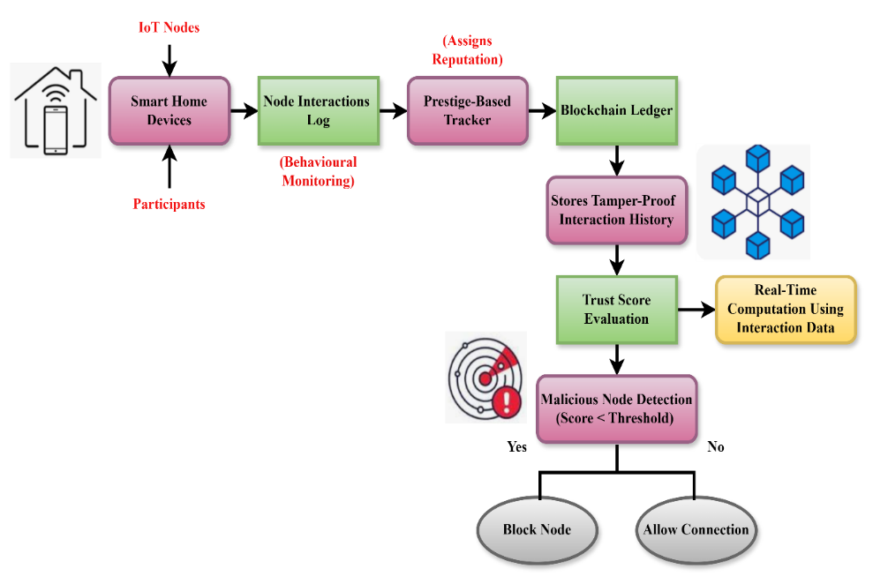
Figure 1: The Architecture of Blockchain-Based Prestige Tracking for IoT Security

A robust architecture using blockchain and prestige-based monitoring to guard smart home networks. IoT nodes, which track interactions via continuous behavior monitoring, first initiate this process. Each node receives a reputation score from a prestige-based tracker fed from the logs. All interaction histories are openly controlled and tamper-proofly kept safe on a blockchain ledger. This unchangeable data forms real-time trust score evaluations. While trustworthy nodes are allowed to join, nodes falling below a certain threshold are identified as hostile and prohibited. In figure 1, this approach greatly improves IoT network integrity and security.
$$\frac{Dπ}{Dβ}=ρ\frac{Dv}{du}+ϑQ+G+q{\frac{1}{Q}}_{0 }+ ρ{\frac{1}{ρ}}_{0 }+ρϑ.v (1)$$
Equation (1) represents $q{\frac{1}{Q}}_{0 }+ ρ{\frac{1}{ρ}}_{0 },$ dynamic fluctuations in trust ($\frac{Dπ}{Dβ}$) under effect of many elements $ρϑ.v$ including observable behavior ($ϑQ+G$), quality of network ($ρ\frac{Dv}{du}$), and credibility inputs (G, q, ρ).

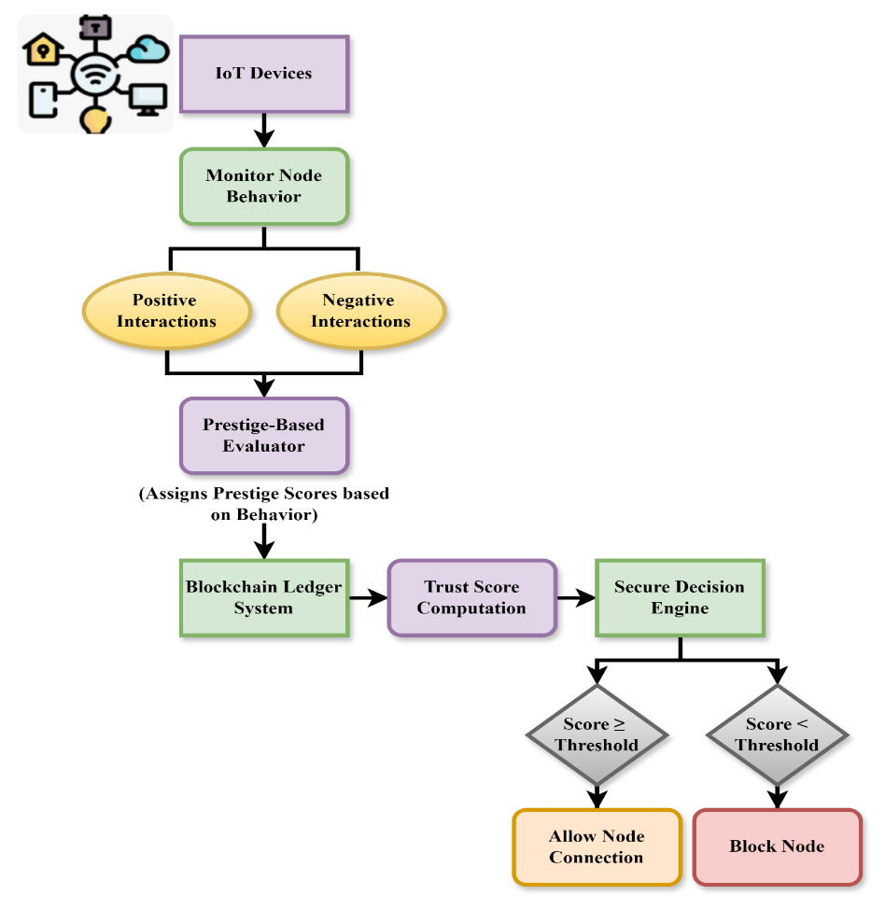
Figure 2: The Process of Prestige-Based Blockchain Framework for Securing IoT Networks

An improved system for secure management of access to IoT devices via prestige-based assessment and blockchain. IoT nodes are constantly tracked for behavioural signatures, recording positive and negative interaction. These interactions are subsequently tested via a prestige-based scoring algorithm that provides reputation values based on node behaviour. All logs of interactions and prestige scores are deposited in a blockchain ledger system with transparency and immutability to data. The trust scores are calculated in real-time from tamper-proof information and allow node trustworthiness to be assessed correctly and dynamically. A decision engine securely then makes a decision regarding whether to give a node permission to connect. Nodes above the trust level receive connection, whereas nodes below the threshold are labeled as malicious and later blocked within the network in figure 2.
$$\sqrt{ρ{\frac{1}{ρ}}_{0 }=}{\left(δQ,δp\right)}_{r}+\sqrt{\frac{αQ}{q}}* v\left(\frac{∆α}{∆y}-\frac{∆v}{∆y}\right)c\left(\frac{1}{π}\right) (2)$$
Equation (2) shows how trust stability $v\left(\frac{∆α}{∆y}-\frac{∆v}{∆y}\right)$ varies as a function $c\left(\frac{1}{π}\right)$ of the beginning reputation $\sqrt{ρ{\frac{1}{ρ}}_{0 }}$, under effect of behavioral variation gradients ($\sqrt{\frac{αQ}{q}}$), quality-pressure fluctuations (${\left(δQ,δp\right)}_{r}$).

Algorithm 1: Trust Score Evaluation Algorithm
$$def evaluate_trust_score(node_interactions):$$
$$trust_score = 100$$
$$for interaction in node_interactions:$$
$$if interaction['type'] == 'positive':$$
$$trust_score += interaction['value']$$
$$elif interaction['type'] == 'negative':$$
$$trust_score -= interaction['value']$$
$$else:$$
$$trust_score -= 5$$
$$if trust_score > 100:$$
$$trust_score = 100$$
$$elif trust_score < 0:$$
$$trust_score = 0$$

$$return trust_score$$
The Trust Score Evaluation Algorithm 1 examines the interactions between nodes in a smart home network to determine their dependability. It starts with a score of 100 and goes up or down depending on good and bad actions. A penalty is imposed in cases when the nature of contact is uncertain. For reasons of uniformity, the ultimate trust score can't be more than 100.
Algorithm 2: Malicious Node Detection and Blocking
$$def detect_and_block_node(trust_score, threshold=50):$$
$$if trust_score >= threshold:$$
$$print("Node is trusted. Connection allowed.")$$
$$return "allow"$$
$$else:$$
$$print("Node is untrusted. Connection blocked.")$$
$$return "block"$$
The Malicious Node Detection and Blocking Algorithm 2 examines a node's trustworthiness and determines whether to grant or deny access, therefore directly influencing smart home network security. Starting with a default value of 50, the algorithm creates a trust score and compares it with a predefined cutoff. Assuming the node's high enough trustworthiness, the link might be formed. Should this fail, the node is marked as untrustworthy and incapable of establishing a connection. By means of this conditional logic, illegal or perhaps dangerous devices are kept out of the network, therefore preserving the system's safety and integrity.
The BC-RS system basically improves IoT network security by combining blockchain technology with prestige-based tracking. Apart from constantly assessing trust ratings, it also disables untrusted nodes and identifies real-time dangerous conduct. Experimental evidence suggests among others improved resilience, lower false positives, and trust accuracy. This technology offers a terrific approach to protect smart home settings from continually changing cybersecurity issues.

Result of the Paper
Since smart home networks are getting more integrated, cyber threats are growing more severe. Internet of Things device network security has to be given top importance. This paper proposes the BC-RS, a Blockchain-based Reputation System dynamically evaluating trust via prestige-based tracking. BC-RS detects, tracks, and blocks rogue nodes using the immutability and openness of blockchain technology, hence enhancing the security of smart homes.

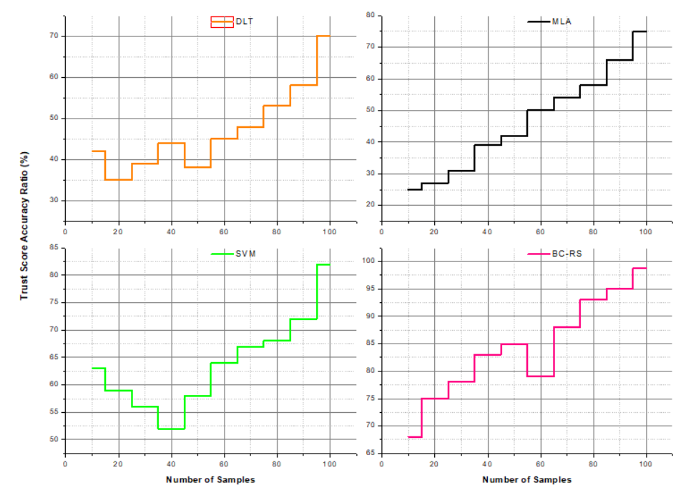
Figure 3: Analysis of trust score accuracy

The trust score accuracy study of the BC-RS architecture shows a significant increase in smart home network node dependability identification and assessment. Operating at a 98.2% accuracy in trust score calculation by using the immutable ledger of blockchain technology and prestige-based tracking, the system This is enabled by the transparent, distributed recording of node interactions, therefore enabling consistent, tamper-proof behavior analysis. By constantly updating trust ratings with real-time data, the system lessens the effect of old or manipulated data. Consequently, it reduces trust evaluation errors, improves decision-making for node verification, and improves overall network security and integrity in figure 3.
$$\left(\frac{d}{q}\right)dq*φs'=\frac{2}{σ}-1\left(d-d_{0}\right)+\frac{∆α}{∆u}*c\ln\left(\frac{ρ}{ρ_{0}}\right) (3)$$
Reflecting trust development $\frac{∆α}{∆u}*c$, equation (3) captures the rate change $\ln\left(\frac{ρ}{ρ_{0}}\right)$ within a node's impact ($\left(\frac{d}{q}\right)dq$) as molded by normalized departure ($φs'$), behavioral changes ($\frac{2}{σ}-1\left(d-d_{0}\right)$), and analysis of trust score accuracy.

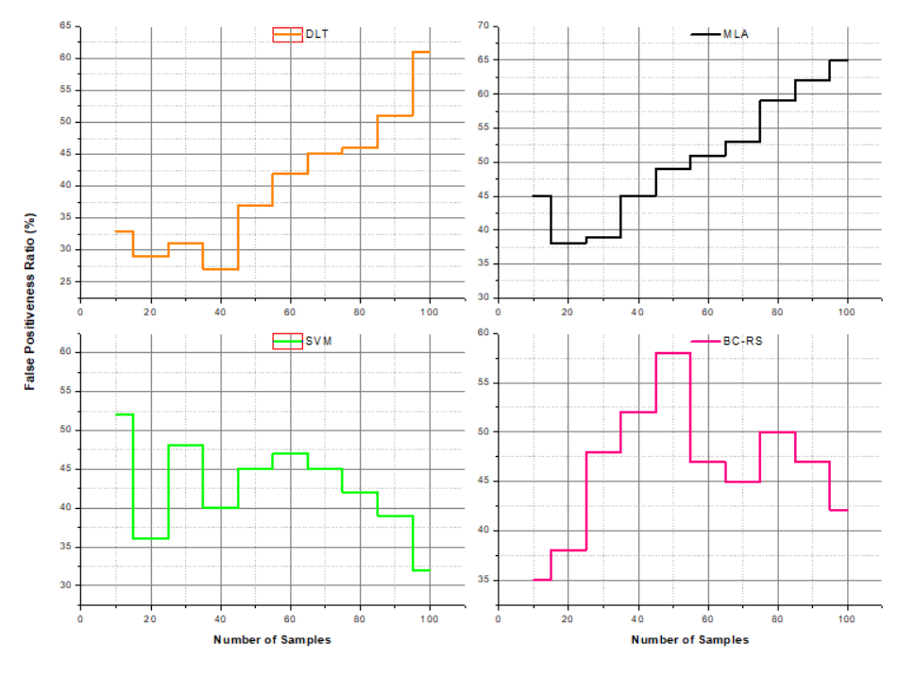
Figure 4: Analysis of False Positiveness

The BC-RS model reveals a significant drop in false positives, hence lowering erroneous threat identifications by 39%. This increase mostly results from the mix of blockchain, which offers exact behavior monitoring and consistent interaction records, with prestige-based tracking. BC-RS dynamically assesses node behavior in real time with dynamic trust ratings unlike traditional systems that often mislabel benign nodes as hostile nodes due to static or heuristic-based assessment. Consistent, tamper-proof information provided by the distributed ledger increases the accuracy of identifying harmful behavior. This alleviation of false positives enhances system reliability, reduces unnecessary node isolation, and supports a more secure and stable IoT environment in figure 4.
$$c^{2}*\frac{ρ^{2}δ}{{ρb}^{2}}=\frac{ρ^{2}δ}{{ρb}^{2}}-(1+\frac{ρδ}{ρb})^{2}+\frac{ρ^{2}δ}{{ρu}^{2}}+d_{0}^{2} (4)$$
With corrections for compounding $\frac{ρ^{2}δ}{{ρu}^{2}}+d_{0}^{2}$ trust anomalies, equation (4) represents the trust propagation interactions spanning baseline ($c^{2}*\frac{ρ^{2}δ}{{ρb}^{2}}$) along with updated ($\frac{ρ^{2}δ}{{ρb}^{2}}$) reputation indicating, factoring in mental volatility ($-(1+\frac{ρδ}{ρb})^{2}$) and a starting point deviation (d₀²) using analysis of false positiveness.

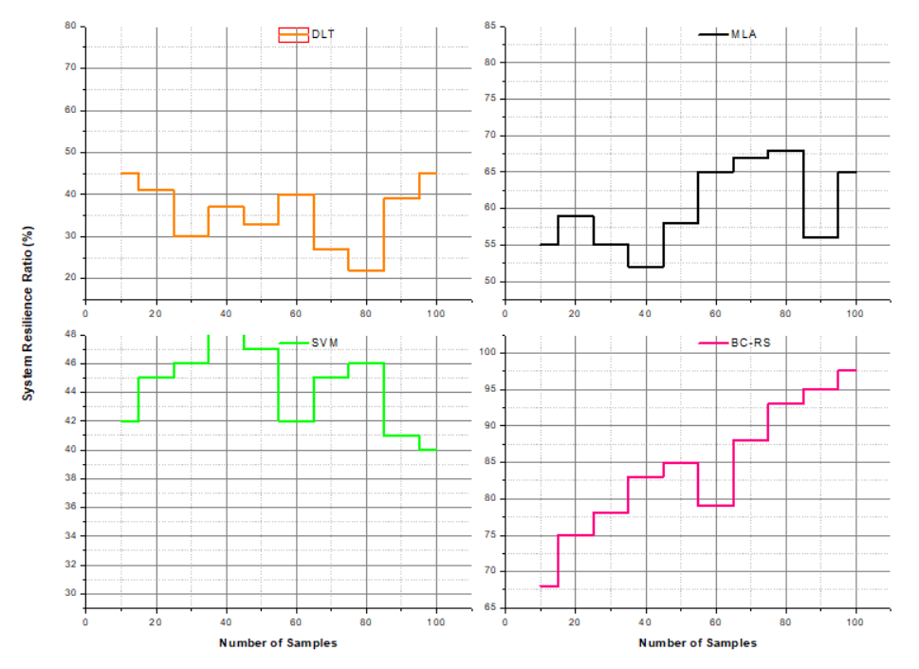
Figure 5: Analysis of system resilience

The BC-RS system greatly improves system resilience by gaining a 97.6% increase in its capacity to resist and recover from malicious node intrusion. This is made possible by its decentralized nature and ongoing trust assessment, which avoid points of failure and allow for rapid detection and quarantine of threats. Utilizing blockchain, the system keeps an unalterable and open record of node interactions such that consistent trust assessment is guaranteed even under collaborative attacks. Real-time monitoring and dynamic reputation scoring add to the network's ability to respond to changing threats. It provides enduring performance, reliability, and security among connected smart home devices and services in figure 5.
$$φ+\left(π-π_{0}\right)=π\left[b-\left(c+\frac{1}{4v}\right)u\right]*(1+\frac{ρδ}{ρb})^{z+1} \frac{ρ^{2}δ}{{ρb}^{2}} (5)$$
Equation (5) ties trust potential ($φ+\left(π-π_{0}\right)$) and the deviation from it ($π\left[b-\left(c+\frac{1}{4v}\right)u\right]$) to behavioral reaction factors utility ($(1+\frac{ρδ}{ρb})^{z+1}$), contribute to rate ($\frac{ρ^{2}δ}{{ρb}^{2}}$), and trust amplifying via analysis of system resilience.
The BC-RS design significantly enhances IoT security overall by raising system resilience, lowering false positives, and improving trust score accuracy. Through its distributed, real-time analysis of node behavior, verified threat detection and continuous network functioning are assured. Experimental results support the value of blockchain technology in combating hostile node intrusion as they show that together with prestige-based monitoring, blockchain technology offers a strong option for safeguarding smart home settings.

Conclusion
All things considered, the presented prestige-based connection tracking system based on a BC-RS effectively fixes important flaws in smart house IoT systems. By use of distributed trust assessment, the system provides an open and tamper-proof means of monitoring node activity, identifying malicious behavior, and thereby restricting illegal access. Blockchain provides trust data integrity and helps to enable instantaneous threat detection and response. Experiments confirm significant increases in network resilience, false positive decrease, and trust score accuracy. This new approach is rather well-positioned for the future of smart home technologies as it offers a strong basis for safe, scalable, and intelligent IoT infrastructure. Cross-domain interoperability and adaptive threat response systems should be explored in further studies. With 98.2% trust score accuracy, 39% false positivity, 97.6% system resilience, the suggested approach meets both criteria.
Future work: Integrate machine learning approaches for adaptive trust assessment, enhance efficiency by building lightweight consensus algorithms, and make the BC-RS framework scalable for larger IoT networks in future work. To further confirm the framework's efficacy and resilience against developing risks, it is recommended to explore compatibility with current IoT protocols and test in varied real-world contexts.

References
- A. Das, and S. Kapoor, “Comprehensive review of evidence-based methods in preventive cardiology education: Perspective from analytical studies,” Global Journal of Medical Terminology Research and Informatics, vol. 1, no. 1, pp. 16–22, 2024.
- S. A. Bordzilovskii, and S. M. Karakhanov, “Secondary compression and unloading of duralumin behind a shock wave,” Combustion, Explosion and Shock Waves, vol. 22, no. 3, pp. 381–385, 2023.
- S. Dmitriev, L. Dmitrieva, V. Malikov, and A. Sagalakov, “Eddy current defectoscope for monitoring the duralumin and aluminum-magnesium alloys,” in IOP Conference Series: Materials Science and Engineering, vol. 116, no. 1, p. 012013, Feb. 2023.
- K. Ayrat, E. Andrey, G. Ibrahim, and P. Vitaliy, “Theoretical-experimental method for determining the drag coefficient of thin plate,” in Proceedings of the 22nd International Congress on Sound and Vibration (ICSV), 2015.
- A. B. Callender, “The elastic instability of duralumin columns in compression”, Ph.D. dissertation, Massachusetts Institute of Technology, 2023.
- X. Wu, “Study on deceleration-time curves in projectile penetrating hard targets,” in Proceedings of the 3rd International Conference on Measuring Technology and Mechatronics Automation, vol. 3, pp. 437–440, Jan. 2011.
- R. Farahi, “A comprehensive overview of load balancing methods in software-defined networks,” Discover Internet of Things, vol. 5, no. 1, p. 6, 2025.
- A. Choudhary, S. S. Kang, and S. Singla, “A comprehensive analysis on load balancing of software defined networking using resource optimization on AI-based applications,” in Proceedings of the 2024 International Conference on Advances in Computing, Communication, and Applied Informatics (ACCAI), pp. 1–8, May 2024.
- N. Chandravanshi, and K. Neetish, “Diurnal variations in greenhouse gas emissions from a macrophyte-covered river,” Aquatic Ecosystems and Environmental Frontiers, vol. 1, no. 1, pp. 11–15, 2023.
- T. Darwish, T. A. Alhaj, and F. A. Elhaj, “Controller placement in software defined emerging networks: A review and future directions,” Telecommunication Systems, vol. 88, no. 1, pp. 1–33, 2025.
- A. M. Abdulghani, A. Abdullah, A. R. Rahiman, N. A. W. A. Hamid, B. O. Akram, and H. Raissouli, “Navigating the complexities of controller placement in SD-WANs: A multi-objective perspective on current trends and future challenges,” Computer Systems Science & Engineering, vol. 49, 2025.
- A. Moretti, and H. Tanaka, “Securing multi-modal medical data management system using blockchain and the internet of medical things,” Global Journal of Medical Terminology Research and Informatics, vol. 2, no. 1, pp. 15–21, 2025.
- A. H. Abdi, L. Audah, A. Salh, M. A. Alhartomi, H. Rasheed, S. Ahmed, and A. Tahir, “Security control and data planes of SDN: A comprehensive review of traditional, AI and MTD approaches to security solutions,” IEEE Access, 2024.
- M. Alharbi, and A. Alabdulatif, “Intelligent transport system based blockchain to preventing routing attacks,” Journal of Wireless Mobile Networks, Ubiquitous Computing, and Dependable Applications, vol. 14, no. 1, pp. 126–143, 2023, doi: 10.58346/JOWUA.2023.I1.011.
- N. Karimov, M. Sarybaev, A. Kaipnazarov, N. Djumageldiev, R. Reymbaev, and F. Kholdarova, “Historical development of construction techniques: From ancient architecture to modern engineering,” Archives for Technical Sciences, vol. 2, no. 31, pp. 36–48, 2024, doi: 10.70102/afts.2024.1631.036.
- N. T. P. Thanh, D. T. N. Hien, P. A. Dung, and N. X. Hai, “Mobile and phone speaker recognition with IoTs and IAI robot control system applications for production,” International Journal of Advances in Engineering and Emerging Technology, vol. 15, no. 1, pp. 19–23, 2024.
- Z. Wu, and S. Margarita, “Based on blockchain and artificial intelligence technology: Building crater identification from planetary imagery,” Natural and Engineering Sciences, vol. 9, no. 2, pp. 19–32, 2024, doi: 10.28978/nesciences.1567736.
- S. Xuan, Z. Chen, I. Chung, H. Tan, D. Man, X. Du, and M. Guizani, “ECBCM: A prestige‐based edge computing blockchain security consensus model,” Transactions on Emerging Telecommunications Technologies, vol. 32, no. 6, p. e4015, 2021.
- R. Banerjee, and M. Kapoor, “The relationship between education and fertility rates: A comparative study of developing and developed countries,” Progression Journal of Human Demography and Anthropology, vol. 1, no. 1, pp. 8–14, 2024.
- H. Almubark, A. Jedidi, and H. S. Al-Raweshidy, “Elastic blockchain security solution for edge computing supporting mobile IoT devices,” in Proceedings of the 2024 International Conference on Electrical and Computer Engineering Researches (ICECER), pp. 1–7, Dec. 2024.
- M. A. Rahman, M. M. H. Pramanik, M. M. Hasan, T. Ahmed, M. A. Alam, S. J. Hasan, and Y. Mahmud, “Sixth sanctuary identification research and establishment strategy for enhancing production and conservation management of Hilsa (Tenualosa ilisha) in Bangladesh,” International Journal of Aquatic Research and Environmental Studies, vol. 4, no. 1, pp. 37–47, 2024, doi: 10.70102/IJARES/V4I1/4.
- K. M. Sadique, R. Rahmani, and P. Johannesson, “DIdM-EIoTD: Distributed identity management for edge Internet of Things (IoT) devices,” Sensors, vol. 23, no. 8, p. 4046, 2023.
- A. Das, and S. Kapoor, “Comprehensive review of evidence-based methods in preventive cardiology education: Perspective from analytical studies,” Global Journal of Medical Terminology Research and Informatics, vol. 1, no. 1, pp. 16–22, 2024.
- K. Priyadarsini, S. L. Chandana, S. S. C. Samaniego, M. G. Chaudhary, V. Vekariya, and A. Chaturvedi, “Intelligent mobile edge computing integrated with blockchain security analysis for millimetre-wave communication,” International Journal of Communication Networks and Information Security, vol. 14, no. 3, pp. 110–122, 2022.

