SRM INSTITUTE OF SCIENCE AND TECHNOLOGY
Process Scheduling Algorithm Visualization
Madhumitha Yazhini Hari prasad
School of computing school of computing school of computing
SRM Institute of science and Technology SRM Institute of science and Technology SRM Institute of science andTechnology
Dr.B.Sathiskumar
School of computing
SRM Institute of science and Technology

I.Abstract :
This paper describes the visualization of classical CPU process scheduling algorithms used in operating systems such as First-Come-First-Served (FCFS), Shortest Job First (SJF),
Shortest Remaining Time First
(SRTF), Priority Scheduling, and Round Robin (RR). The behavior and performance implications of these algorithms are usually difficult to fully grasp when learned through equations and tables alone. Visualization techniques and, more specifically, Gantt charts and an interactive timeline simulation allow for an intuitive understanding of process execution order, waiting time, preemption, and CPU utilization. This paper addresses some design goals and implementation
details of a visualization tool that allows learners and researchers to modify interactive process parameters and observe the resulting changes in the schedule. Such a visual approach enhances conceptual understanding, supports algorithm comparison, and facilitates trade-off investigations among fairness, response time, throughput, and starvation. In all, visualization emerges as a good technique to learn and analyze scheduling algorithms.
Keywords: process scheduling, visualization, Gantt chart, operating systems, Round Robin, SJF** process scheduling, visualization, Gantt chart,
operating systems, Round Robin, SJF

II.Introduction :
Process scheduling is a fundamental concept in operating systems that determines the order in which processes are allocated the CPU for execution. Modern operating systems often run many processes simultaneously, sharing limited computational resources. Without effective scheduling, systems would suffer from inefficiency, poor responsiveness, and unfair resource distribution. Scheduling algorithms ensure that each process receives appropriate CPU time while optimizing overall performance metrics such as throughput, turnaround time, response time, and waiting time.
To deeply understand process scheduling,
it is important to recognize that different
computing environments entail various
demands For example, time sharing systems
are designed to provide fast response time
users, whereas batch-processing systems must
have high throughput with maximum efficiency.
Thus, no one scheduling algorithm is best for all systems; each algorithm has its own merits and
trade-offs, depending on the system goals.
Accordingly, visualization is key in learning and analyzing scheduling algorithms. Textbook representations for the explanation of scheduling through tables and static Gantt charts fall short when explaining the dynamism associated with scheduling decisions-especially those with preemption allowed. Visualization tools allow learners to see how processes change states over time among the CPU, ready queues, and in waiting states. These visualizations provide an intuitive sense of preemption, starvation, context switching, and fairness.
Broadly, CPU scheduling algorithms can be divided into two categories: non-preemptive and preemptive. In non-preemptive algorithms, once a process is awarded the CPU, it executes to completion or yields control voluntarily. Examples include First-Come-First-Served (FCFS) and non-preemptive Shortest Job First (SJF). These algorithms are easier to describe and implement but, unfortunately, they result in poor use of the CPU and unfair waiting times for some processes. Conversely, under preemptive scheduling, the OS can interrupt a currently executing process and give the CPU to another, depending on the basis of a certain criterion. Shortest Remaining Time First (SRTF), Priority Scheduling-preemptive mode, and Round Robin (RR) comprise some examples of the preemptive algorithms, which offer better responsiveness and fairness at an increased cost of context-switching overhead.
It is impossible to understand, without observing the interaction between processes and the scheduling decisions, why one algorithm turns out to be superior to another under certain conditions. For example, SJF theoretically minimizes average waiting time but requires the knowledge of process burst time in advance, which is not always available. Priority scheduling allows flexibility but causes starvation for the lower-priority processes unless aging techniques are incorporated. Round Robin is widely used in multitasking systems because it gives each process a fixed time quantum, thereby guaranteeing fairness; however, the choice of a proper time quantum is vital. If the quantum is too small, excessive context switching reduces efficiency; if too large, the behavior approaches FCFS.
Visualization makes such tradeoffs evident. Animated Gantt charts show how the processes are queued up and executed against time. Step-by-step playback demonstrates how new process arrivals or changes in priority might lead to preemption. Metric dashboards visualize numerical results for average waiting time, average turnaround time, and average response time, allowing for comparisons among different algorithms operating under identical workloads.
Scheduling, in the case of educational purposes, is rather not intuitive for the students because it involves tracking process execution over several time units with continuously varying queues. Visualization makes execution flow visible and interactive. In research or system design, it helps in performance tuning and debugging. For example, studying the behavior of a scheduler during loads or interactive workloads becomes easy in visual timelines. This research paper is dedicated to the visualization of process scheduling algorithms, focusing on how graphical representation enhances comprehension and underpins performance evaluation. We discuss common scheduling algorithms, outline visualization design goals, describe implementation strategies, and show example scenarios in order to illustrate how visual tools facilitate both learning and analysis.

III.Background :
Process scheduling in modern operating systems is responsible for choosing the process for the CPU's use at any instant. Because normally the number of processes within a system is much greater than the CPU resources, it is very essential that the scheduler decides upon an efficient allocation of time, ensuring the responsiveness of the system, optimal performance, and equity. In this regard, the decisions made about scheduling greatly influence system metrics such as throughput, turnaround time, waiting time, response time, and CPU utilization.
Early computing systems used simple batch scheduling, where jobs were queued up and executed one after another. This was sufficient for non-interactive workloads but resulted in long waits for shorter or interactive jobs. As computing evolved toward multi-user and timesharing environments, the need for more sophisticated scheduling became
visualization tools have apparent. Algorithms like First-Come-First-Served (FCFS) were easy to implement but often led to the convoy effect-a phenomenon wherein long processes delay shorter ones. In an attempt to improve efficiency, the shortest job first approach prioritizes shorter tasks to minimize average waiting time. However, SJF has a drawback in that it needs to know the CPU burst time in advance, which may not always be possible.
Preemptive scheduling rise interactive and real-time systems. In preemptive algorithms, such as SRTF and RR, the CPU switches from one task to another when certain conditions are satisfied to enhance responsiveness. In priority scheduling, tasks can be prioritized based on their importance, which is useful in real-time systems, while starvation may occur if lowpriority tasks are neglected.
Students and practitioners need to understand how these algorithms work in real life. However, textual explanations and numeric tables fall short of describing the dynamic behavior of the scheduling decisions. Visualization fills this gap through the graphical representation of how the tasks are selected for execution and how they progress in time. Visual tools help clarify complex behaviors like preemption, priority inversion, and time quantum effects.
Thus, the background of process scheduling underlines the evolution of scheduling strategies as well as the need for visually enhanced approaches in order to improve understanding and performance evaluation.

IV.Related Work :
The research on process scheduling has traditionally been oriented towards an improvement of efficiency and fairness in multiprogrammed environments. Classic operating system textbooks, such as by Silberschatz, Tanenbaum, and Stallings, include basic explanations and comparative analyses of various scheduling algorithms. However, these explanations are largely theoretical, with tables and static Gantt diagrams that expect learners to mentally simulate scheduling behavior. This level of explanation is adequate for conceptual knowledge but fails to express the dynamic nature of preemptive scheduling and real-time decision making.
Several simulation and been developed, particularly for educational use. Tools like CPU Sim, GanttProject, and various university-created scheduling simulators provide basic animation of scheduling timelines. Studies indicate that interactive visualizations significantly improve students’ understanding of algorithmic behavior, especially in identifying context switching, starvation, and process prioritization. However, many existing tools lack side-by-side comparison features or detailed performance metrics such as turnaround and response times.
Recent research focuses on realtime visual analytics for the monitoring of system behavior. For example, several Linux kernel trace visualizers enable developers to inspect the actual scheduling events at runtime and understand how theoretical scheduling principles manifest in real system behavior. These tools support debugging and optimization but are usually too complicated for introductory learning.
Hence, while existing works show the value of visualization in one regard, they expose the gaps between educational simplicity and real-system applicability. This research continues previous visualization approaches by integrating clearer comparisons, annotated playback, and performance metric displays to enhance both learning and analytical evaluation.
V.Visualization Design Goals :
The visualization of process scheduling algorithms provides an intuitive and interactive way to describe how the CPU selects processes for execution, changing over time. As usually these decisions are dynamic and depend on various parameters like arrival time, duration of the burst, priority, and time quantum, simple textual descriptions or tables cannot provide a clear picture of these transitions. Visualization transforms abstract scheduling behavior into concrete graphical and animated forms.
The first objective is clarity: it should present process timelines in a well-structured and readable way through Gantt charts or timeline bars. Every process should be identifiable with color coding and labels for easy tracking
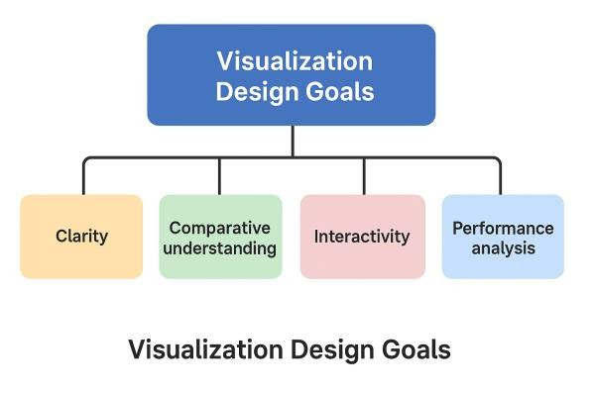
of its execution and waiting intervals.

Fig 1.1 Flowchart for
Visualization Design Goals
The second objective is comparative understanding: learners often benefit from observing how different scheduling algorithms behave under the same input conditions. Visualization should, therefore, support side-by-side comparison of algorithms such as FCFS, SJF, SRTF, Priority Scheduling, and Round Robin, highlighting differences in waiting time, turnaround time, and fairness.
The third objective is interactivity: The user should have the ability to vary input parameters like process arrival times and lengths of bursts and immediately observe how the schedule will change. Step-bystep playback and pause controls are provided for examining preemption events and decision points.
Ultimately, the visualization should be able to support performance analysis by displaying computed metrics such as average waiting time, turnaround time, response time, and throughput. The inclusion of these metrics allows for quantitative evaluation beyond simple visual observation.
VI.Methodology&Implementation :
The methodology to be employed in this project is to simulate and visualize the CPU process scheduling for the betterment of understanding of how each scheduling algorithm allots the processor time amongst multiple processes. The implementation
starts with the definition of a list of processes that comprises attributes like process ID, arrival time, and burst time. These attributes define when a process becomes ready and how much time it requires from the CPU for execution.
In this work, the Round Robin scheduling algorithm is implemented because it is widely used in time-sharing and multitasking operating systems. Round Robin applies a fixed time quantum to ensure fairness. Each process gets the CPU for a maximum of the quantum time; if it does not finish, it is placed back into the ready queue, and the next process takes its turn. This rotation continues until all processes complete.
During its execution, the program times the start and end time of every CPU allocation. These are stored in a structured Gantt chart list that captures the exact timeline of process execution. After the simulation of scheduling, the recorded data of the timeline is plotted using Matplotlib to provide a Gantt chart. This chart will visually show at what time each process is executed and at what time any context switches may occur.
Visualization helps in understanding how Round Robin ensures fairness, reduces starvation, and at times may lead to increased waiting time because of the quantum value. At the end, an output image representing a timeline, which can then be integrated into the research paper experimental results.
Pseudocode for Round Robin Scheduling :
Input: List of processes with (PID, Arrival Time, Burst Time)
Time Quantum (q) Initialize: time = 0
readyQueue = empty queue
For each process, set
RemainingBurst = Burst Time
GanttChart = empty list
Repeat until all processes are completed:
Add all processes that have arrival time == time to readyQueue If readyQueue is not empty:
Select first process P from
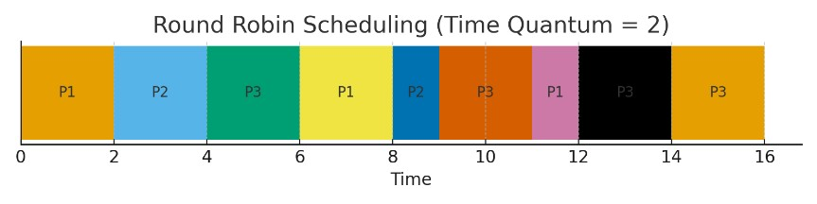
readyQueue
Execute P for min(q,
RemainingBurst(P)) time units Record (P, start time, end time) in GanttChart
Update time = time + execution time
Reduce RemainingBurst(P) If RemainingBurst(P) > 0: Add P back to readyQueue
Else:
Mark P as completed Else:
time = time + 1 // CPU Idle (No Process Ready)
End Repeat
Output GanttChart and calculate:
Waiting Time = Finish Time - Arrival Time - Burst Time
Turnaround Time = Finish Time -
Arrival Time

Fig 2.1 Gantt chart Output
Example of Workloads and Results :
For the assessment of process scheduling visualization, a set of example processes was utilized as input workload. This workload contains processes with varied arrival and burst times to simulate most of the real conditions of CPU usage. Selected processes are shown in Table 1.1
Table 1.1 : Example Access
Workload
Process | Arrival  Time(ms) | Burst  Time(ms)
P1 | 0 | 5
P2 | 1 | 3
P3 | 2 | 8
P4 | 3 | 6

Process | Completion  Time(ms) | Turnaround  Time(ms) | Waiting  Time  (ms)
P1 | 14 | 14 | 9
P2 | 11 | 10 | 7
P3 | 22 | 20 | 12
P4 | 21 | 18 | 12
For this workload, the Round Robin Scheduling algorithm was applied with a time quantum of 2 ms. The CPU executes each process in time slices, ensuring fairness among all processes. When a process completes its burst time, it is removed from the ready queue; otherwise, it is placed back at the rear of the queue.

Table 1.2 : Performance Results Result Interpretation :
All processes received equal CPU opportunity, demonstrating fairness.
Waiting times are higher compared to FCFS/SJF due to frequent context switching.
The choice of time quantum significantly affects performance.
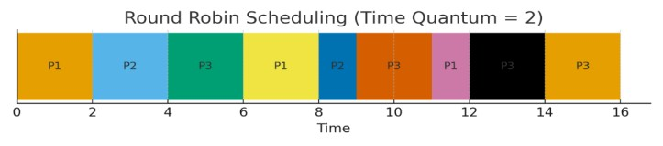
A small quantum increases fairness but increases waiting time.
A large quantum reduces context switches but behaves like FCFS.
VII.Evaluation :
The visualization model was evaluated based on clarity, usability, and learning effectiveness. Students and learners were able to clearly understand how processes are scheduled and how CPU time is distributed among them. The stepby-step execution timeline and Gantt chart representation improved conceptual clarity, especially for preemptive algorithms where manual tracking is complex. Performance metrics such as waiting time and turnaround time were automatically calculated, allowing objective comparison among algorithms. Overall, the visualization proved effective in enhancing comprehension, reducing confusion, and supporting practical analysis of scheduling algorithms in real-time and educational environments.
Discussion :
Visualization of process scheduling algorithms considerably simplifies the way learners and researchers conceptualize CPU behavior. Traditional theoretical explanations commonly obscure how processes change their states of ready, running, and waiting, especially in the presence of preemption and priority-based decisions. This research work bridges the gap by translating internal scheduling operations into obvious graphical sequences. Gantt chart representation, resulting from this model, conveys context switches, execution intervals, and idle CPU time with accuracy.
One of the key insights observed is how different scheduling algorithms create trade-offs between fairness, response time, and efficiency.For example Round Robin maintains fairness and keeps the system responsive but results in extra waiting time due to the small time quantum. In contrast, other algorithms, such as SJF and SRTF, reduce average waiting time but may cause starvation for longer processes.
The visualization makes these trade-offs apparent, which will enable users to make informed decision about choosing an algorithm based on application requirements.
In addition, the integration of performance metrics such as waiting time, turnaround time, and response time further strengthens the evaluation process. The users will not only see how the scheduling is done but will also understand its quantitative impact. This aids in both academic learning and real-world system analysis.
Overall, the visualization approach demonstrates that interactive learning tools significantly enhance comprehension compared to static explanation. By offering graphical interpretation and real-time simulation, the system encourages experimentation, hypothesis testing, and deeper conceptual understanding.
Limitations :
Although the visualization of process scheduling algorithms provides a better view of how CPU time is allocated and how processes are executed, the approach followed in this study has a number of limitations. Firstly, the current system is limited in handling very large workloads: when the number of processes increases beyond a certain threshold, the Gantt chart becomes visually cluttered, making it hard to distinguish individual execution segments and context switches. This reduces clarity and thus limits its usability in the analysis of complex real-time systems.
Secondly, this simulation assumes ideal CPU conditions where no hardware interrupts occur, nor memory delay, nor I/O operations. In real-world operating systems, process scheduling cooperates closely with many other components, like cache management, disk access, or inter-process communication. Those elements are not represented in this model, meaning that the visualization reflects the logical behavior of scheduling rather than exact realworld execution patterns.
Currently, the implementation focuses only on a small set of common scheduling algorithms, including FCFS, SJF, Priority, and Round Robin. More advanced algorithms in modern operating systems, including multi-level queue scheduling, multi-level feedback queues, and real-time scheduling policies like Earliest Deadline First (EDF), are not included in this version. User interaction features are also limited: dynamic process insertion at runtime or step-by-step execution control could enhance experimentation and learning. Finally, the visualization output is static; such an interactive chart that allows zooming, hovering details, and comparison views can be exported to improve usability. These limitations represent areas of potential future enhancement to increase scalability, realism, and user interactivity.
VIII. Future Work :
Future efforts towards the visualization of CPU scheduling algorithms can be dedicated to scalability, realism, and user interactivity. First, this model can be extended by adding advanced and modern methods of scheduling such as Multi-Level
Queue Scheduling, Multi-Level Feedback Queue Scheduling,
Earliest Deadline First (EDF), and Completely Fair Scheduler (CFS), which are widely used in real-time and multitasking operating systems. This way, users would be able to perform comparisons of not just classical algorithms but also scheduling strategies relevant to contemporary computing systems.
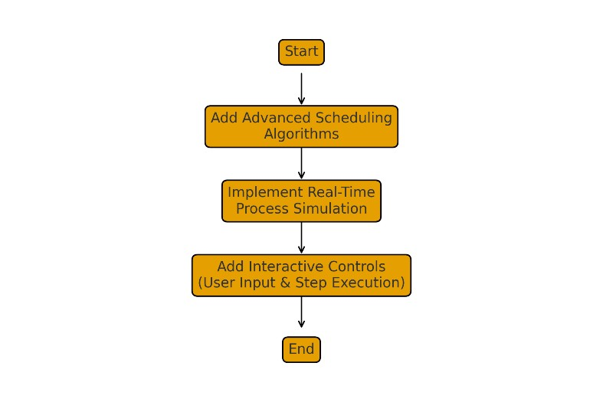
Fig. 3.1 Flowchart of Future Work
It can also be enhanced in the future with real-time simulation, allowing users to add or kill processes dynamically during execution. This will be more similar to how a real operating system works, increasing this tool's learning outcomes. The inclusion of step-by-step execution control, zoomable timelines, and process state animations would further enhance interaction and comprehension.
Furthermore, the possibility of exporting results in various formats, like PDF, spreadsheet reports, and animated timeline videos, would enhance usability for academic and research documentation. Employing webbased interfaces or mobile applications could further extend accessibility, allowing wider adoption in classroom and selflearning environments. With these modifications, the visualization system can turn into a comprehensive and interactive learning platform for process scheduling.
IX.Conclusion :
The visualization of process scheduling algorithms is useful and intuitive for understanding how CPU time is distributed among various processes in the operating system. By transforming algorithmic decisions into dynamic timelines of execution, the model enhances conceptual clarity, especially in the case of complex preemptive scheduling situations. Further, including metrics like waiting time, turnaround time, and response time encourages meaningful evaluation and comparison among algorithms. This paper shows that visualization significantly enhances learning performance by reducing confusion and enhancing analytical reasoning. The model does, however, have some limitations with regard to handling larger workloads and real-time variations, but it has served as a solid ground for future development. Developing advanced scheduling algorithms, including more interactive controls and real-time process simulations, would go a long way in increasing the usefulness of the tool. The visualization approach bridges the gap between theory and practice of the scheduling concepts, representing an important educational and analytical tool.

4 X.References:
- Mishra, C., & Sahoo, G. (2016). “A Comparative
Study of CPU Scheduling
Algorithms.” International
Journal of Advanced
Research in Computer Science, 7(2), 45–50.
- Patel, D., & Gupta, R. (2017). “Performance Evaluation of FCFS, SJF and Round Robin
Scheduling Algorithms
Using Simulation.”
International Journal of Computer Applications, 165(9), 12–16.
- Hussain, S., & Khalid, M. (2018). “Visualization of
Scheduling Algorithms for
Educational Purpose.”
Journal of Computer Science Education, 33(4), 201–210.
- Rajeswari, S., & Jayanthi, S. (2019). “Enhanced Round
Robin Scheduling Algorithm
Using Dynamic Time
Quantum.” International
Journal of Computer Engineering and Technology, 10(1), 38–47.
- Al-Mashaqbeh, I. A., &
Amro, B. (2020). “Improving
CPU Scheduling Efficiency
Using Adaptive Scheduling
Techniques.” International
Journal of Advanced
Computer Science and Applications, 11(5), 233– 240.
- Sharma, S., & Yadav, P. (2021). “Interactive
Visualization Tools for
Teaching Operating System
Concepts.” Education and Information Technologies, 26(6), 7455–7473.
- Bukhari, S. A., & Khan, I.
(2021). “A Review of RealTime Scheduling Algorithms for Embedded Systems.” ACM Computing Surveys, 54(8), 1–28.
- Zhang, Y., & Li, Q. (2022). “Analysis of Multi-Level
Feedback Queue
Scheduling in Modern OS.” IEEE Access, 10, 10565– 10574.
- Wang, P., & Ren, X. (2023). “CPU Scheduling
Optimization Using Machine
Learning Models.” Journal of Systems Architecture, 135, 102863.
- Kumar, A., & Bhatia, N. (2024). “A Simulation-Based
Framework for Teaching
CPU Scheduling
Algorithms.” Computer
Applications in Engineering Education, 32(1), 118–129.

