The retrosynthesis and proposed forward synthesis of Peniditerpenoids A, extracted from Mangrove-Sediment-Derived Penicillium sp. for the treatment of Osteoporosis
Haina Wang
School of Chemistry, University of Manchester
kakawang0830@163.com
Abstract. Recently, two natural products, named Peniditerpenoids A and B were extracted from Penicillium sp. SCSIO 41411 in the mangrove-sediment-derived fungus. The former, a di-seco-indole diterpenoid, Peniditerpenoid A has a great effort in treating osteoporosis. Its pharmaceutical mechanism can be simply indicated in the following figure. In literature-studies verified that Peniditerpenoid A successfully inhibited the activation of TAK1 and then prevented the phosphorylation of I_{k}B$α$ and the translocation of the p65 cell – the subunit of NF-kB. Besides, the levels of NF-kB activation and NFATc1 transcription were both reduced to some extent. Finally, the differentiation of RANKL-induced osteoclasts in bones was eliminated obviously, and the symptoms of osteoporosis gradually got better. Therefore, it is necessary to explore the chemical synthesis of this natural molecule. In the following paper, the basic concepts of retrosynthesis strategy were first introduced and then focused on the whole synthetic pathways of Peniditerpenoid A by using the sense of forward retrosynthesis result in organic chemistry fields. To be aware, the result relied on the theoretical result rather than experimental support.
Keywords: Peniditerpenoid, retrosynthesis, synthesis, carbonyl, organic.

Introduction
Peniditerpenoid A, an intriguing compound isolated from the Mangrove-Sediment-Derived fungus Penicillium sp. SCSIO 41411, exemplifies the diverse and complex characteristics of natural products derived from unique and mysterious ecosystems. This peniditerpenoid stands out due to its intricate terpenoid framework and notable bioactivity.[1,2] The molecule's sophisticated structure, characterized by fused ring systems and multiple chiral centers, simultaneously presents significant synthetic challenges and opportunities. Moreover, organic synthesis has made substantial strides in addressing such complexities through advanced retrosynthetic and forward synthesis strategies. Generally speaking, the retrosynthetic analysis involves the diplomatic disassembly of the target molecule into simpler puzzles, and more accessible fragments, thereby facilitating the design of an efficient synthetic pathway.[3] Conversely, forward synthesis encompasses the systematic assembly of the target molecule from readily available precursors, leveraging innovative reactions and techniques to overcome synthetic obstacles.[4,5] This paper delineates the retrosynthetic strategy employed for Peniditerpenoid A, offering a detailed dissection of its structure into manageable synthetic targets. It further outlines the forward synthesis approach, describing the specific reactions and methodologies utilized to construct the compound. Through these strategic examples, the study aims to advance the understanding of complex natural product synthesis and contribute to the broader field of organic chemistry.
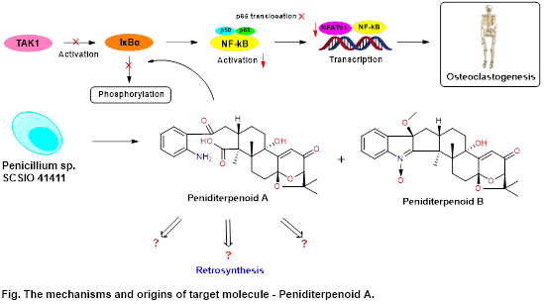
Figure 1. The mechanisms and origins of target molecule – Peniditerpenoid A.

Principals
The strategy in organic chemistry used to find the pathway to generate desired products is commonly called retrosynthesis. Retrosynthesis analysis is an essential method in computer-aided organic synthesis. Its accurate predictions of reactants-components can take some effort to find much more optimized reaction pathways from various possible reactions.[6] This mind is starting from the basics considering converting the triangles to little fragments by disconnecting the lines between the spots. Then continuing to figure out the more complicated ones, for instance, from propane, cyclopropane, cyclohexane to decalin. Once the bonds were broken, there would be some choices of charge separations (Figure 1). The molecules involved in charges are called “synthons”; after functional group addition, they are called “synthetic equivalents”.
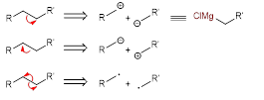
Figure 2. The three different consequences of one bond breaking, forming corresponding sythons with different charge separations.
For complex bridged or polycyclic structures like the following molecule (Figure 2), firstly, find the atoms present in multi-rings and then strategically disconnect the bonds between those atoms. The amount of broken bonds can be either one or two, depending on the structure and its corresponding reaction conditions.
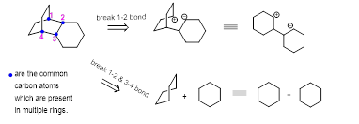
Figure 3. Two methods of disconnecting bonds in a same bridged-structure molecule.
The more common situation used in this paper is observing the potential dioxygenation patterns in a molecule, thinking about both the known and available forward synthesis, and disconnecting the bonds. There is an example to show the complete retrosynthesis and synthesis processes of Wieland-Miescher Ketone (Figure 3).[7] Afterward, dealing with the retrosynthesis and the forward synthesis processes of the natural target molecule Peniditerpenoid A in a similar way.
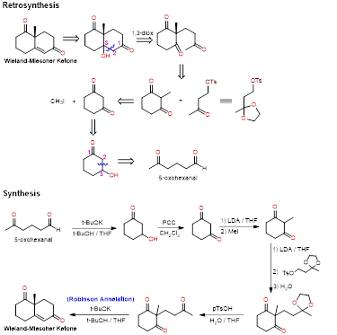
Figure 4. The whole retrosynthesis and synthesis processes of Wieland-Miescher Ketone as an induced example.

Approach
For the retrosynthesis of Peniditerpenoid A, there are four important tactics with the orders of analyzing the oxidation levels and oxygenation patterns, finding the relationship between each function group, trying to do the reasonable bond disconnection, and thinking about the availability of forward synthesis such as the choice of protecting group as the example before. Firstly, forced on the oxidation level analyzation on the right-hand side. The oxidation level depends on the number of electronegative atoms bonded to the target carbon atom, as shown in Figure 4.
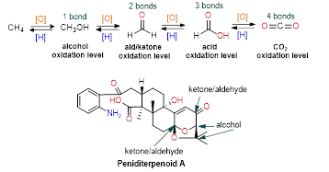
Figure 5. Four types of oxidation levels in organic chemistry (up) and the analyzation of oxidation levels on the right-hand-side part of the target molecule - Peniditerpenoid A (down).
It helps to open the dioxabicycloctane structure to get the result of the first-step product of the retrosynthesis of the target molecule (Figure 5).
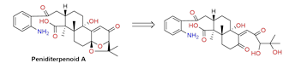
Figure 6. Retrosynthesis of Peniditerpenoid A by opening the ring structure corresponding to the orignal states of its oxidation levels.
Then, considered to break α, β unsaturated olefin in the following structure and added the hydroxyl group (-OH) at β position to generate the 1,3-dioxygenation pattern in the new molecule. The lone pairs in the former hydroxyl group would form a new carbonyl group and disconnect the bond between C2 and C3, the original carbonyl group in C1 was unchanged. Finally, molecules 1 and 2 were formed (Figure 6), and the RHS part of Peniditerpenoid A was removed successfully.
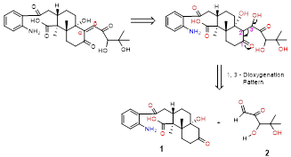
Figure 7. The appropiate alpha or beta positions of hydration, followed by 1,3-dioxygenation pattern bond disconnection, forming molecues 1 and 2.
Further steps illustrated the retrosynthesis of each molecule respectively. Because of the complicated structure of molecule 1, the potential oxygenation patterns should be figured out first. It is obvious to realize that there is a 1,5-dioxygenation carbonyl compound at LHS as well as a 1,3-dioxygenation carbonyl compound at RHS. The strategy was dealing with the difficult part first, so the 1,5-diox pattern was used rather than the other one. Corresponding to the structure, there are two methods to do the disconnection, either the C2-C3 bond breaking or the C3-C4 bond (Figure 7). Besides, when the C3-C4 bond was broken, one of the rings opened which simplified the original structure to some extent, and it was helpful to do the further retrosynthesis, a long straight structure formed at last. In short, the pathway to retrosynthesis molecule 1b is much more sensible than 1a, both of them will be discussed in the remaining content of this paragraph and focused on molecule 1b in detail.
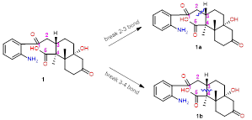
Figure 8. Two methods of bond disconnections of molecule 1, shown as molecues 1a and 1b.
When the C2 and C3 bond was broken, the positive charge was usually allocated in the larger fragment and the negative charge was in the smaller one. Then, an α,β-unsaturated alkene was generated, and the methyl group at α position could be removed. The retrosynthesis result of this methyl group was combined with an electronegative atom to make the C atom partially positively charged. Molecule 1a was reproduced through the “three components coupling” in the forward synthesis process (Figure 8).
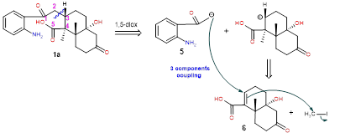
Figure 9. Retrosynthesis of molecule 1a by breaking C2-C3 bond, forming 3 components coupling involves molecules 5, 6 and CH3L
The retrosynthesis of molecule 5 was indicated in Figure 9, forming the products aniline and acetyl chloride.
Figure 10. Retrosynthesis of molecules 5, the retrosynthesis products are aniline and 宙cetyl chloride which both can be found the lab.
For molecule 6, the best strategy for retrosynthesis was using the 1,3-diox pattern, and the bond between C1 and C2 was broken. Therefore, one ring opened and generated a new 1,4-diox carbonyl. Then, the bond C3-C4 was disconnected because it is more complicated to consider the choice of charge separations near the alkene group. The synthon was formed and its synthetic equivalence was molecule 7, shown in Figure 10. However, the linear structure of molecule 7 made it very tough to continue the retrosynthesis. When analyzing the oxygenation patterns that appeared in it, both the left and the right two carbonyls were 1,6-diox pattern and the horizontal chain contained 9 carbon atoms. It was not suitable to form any ring structure among the carbonyls. Even though it had some other choices of breaking bonds, dioxygenation pattern in the second step (1,4-diox), or even disconnecting some specific bond in molecule 7 directly to simplify the structure, taking a look at molecule 1b first.
Figure 11. Retrosynthesis of molecule 6, disconnect C1-C2 bond and then C3-C4 bond, forming molecule 7.
While, for molecule 1b, the aim was to convert the complex multi-ring structure to a linear compound as soon as possible. When the C3 and C4 bond was broken, the positive charge was C3 and the negative charge was C4, so that, an α,β-unsaturated alkene was formed on the top part and the negative charge could also be seen as adding an H atom in the same place and then, used the same strategy for the other ring. There was a 1,3-dioxygenation pattern on the right-hand side, the carbon atoms were renumbered and disconnected the bond between C1 and C4. A 1,4-dioxygenation pattern continually appeared, and the bond C2-C3 was broken. Finally got two synthons, the corresponding synthetic equivalences were acrylic acid and a long linear molecule which was the next target molecule for the retrosynthesis (Figure 11).
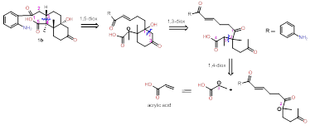
Figure 12. Retroysnthesis of molecule 1b to acrylic acid and a linear molecule, using the strategy of various of dioxygenation patterns.
For the hydration of the olefin, it is essential to judge whether the hydroxide group was added to α or β position. Generally speaking, forming 1,3-diox is always a better choice than 1,2. Because when considering the polarity, the polarity is “consonant” in 1,3-diox and “dissonant” in 1,2-diox. So, the hydroxyl group was added to the β position of the carbonyl that bonded to the R group.
When analyzing the oxygenation patterns in the second molecule, there were both 1,5 and 1,6 dioxygenation carbonyls. However, firstly covered the 1,6-diox pattern due to a much more carbonyl-branched chain, so the bond between C2 and C3 was broken and the other 1,5-diox carbonyl was further likely to generate a five-membered ring. On the other hand, in the next step, the positively-charged carbon and the hydroxide group combined to form an epoxide structure, also epoxide is relatively stable as an intermediate during the synthesis. Two synthetic equivalences 3 and 4 were formed for the final retrosynthesis analysis. What’s more, all the negatively charged carbons can be seen as adding an H atom to them like the following Figure 12.
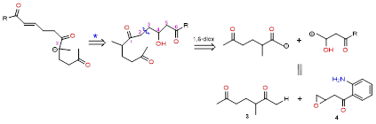
Figure 13. Retroysnthesis of former linear molecule, using 1,6-dioxygenation pattern, forming molecules 3 and 4 with further equivalents.
The retrosynthesis of molecule 3 simply combined the first and the fifth carbon atoms into a five-membered ring, the product called 1,2,3-trimethylcyclopentene. For molecule 4, amine is an ortho-directing group, so the forward synthesis can be directly done by Fridel-Craft acylation. Then, the epoxide can be produced from alkene, but 3-enoyl chloride is formed. Because it is too reactive, so but-3-enoic acid is a better starting material and the forward synthesis is available as well.
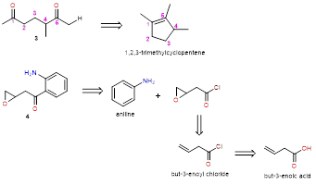
Figure 14. Retroysnthesis of molecules 3 an 4, reaching simple structures, e.g. 1,2,3-trimethylcyclopentene and but-3-enoic acid which are available in lab.
Now, the retrosynthesis of molecule 1b was finished and continued with molecule 2. In Figure 14, 1,2-diox patterns were used twice which were highlighted with arrows. For molecule 2b, the products are two acetaldehydes, while for molecule 2a, the carbonyls were reduced to diols and to ethene finally.
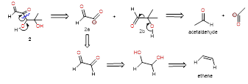
Figure 15. Retroysnthesis (1,2-dicarbonyls) of molecules 2 - forming molecules 2a, 2b and further functionalised products.
To sum up, the target molecule is Peniditerpenoid A, it was divided into two main parts, 1 and 2. Molecule 1a was a detailed example to fully describe the retrosynthesis of molecule 1 and the process of molecule 2 was shown in the above figure. In addition, the named molecules all have their commercial suppliers and they ought to be the starting materials. The whole retrosynthesis can be concluded in the following Figure 15. The first row was the fragments of molecule 1 and the other is for 2.
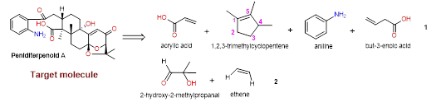
Figure 16. The summary final retrosynthesis products of target natural product - Peniditerpenoid A.

Synthesis & Discussion
At the end of the retrosynthetic analysis, needed to begin discussing the synthetic aspects. The focus was on identifying suitable synthetic routes from existing organic synthesis research and optimizing the yield at each step as much as possible. It is important to realize that the synthesis discussed here is all based on theoretical predictions of separate steps and has not been experimentally validated or tested for practical feasibility. Therefore, based on the current theoretical framework, further research works as well as experimental operations will be indispensable in the future.
According to the former aspect, the target molecule can be synthesized from molecules 1 and 2, forming them first. The methods of forming molecule 2 with the components of 2a and 2b are shown in Figure 16. When ethane-1,2-diol reacted with hydrogen peroxide at 20 °C for 10 hours, forming molecule 2a and the yield is 60 %.[8] Besides, combining methanol,2-hydroxyisobutyramide with zirconium (IV) oxide at 190 °C under 759.826 Torr for 24 hours can generate methyl 2-hydroxy-2-methylpropionate and the yield is almost 95 %.[9] Then, followed by a reduction of ester to aldehyde with dilsobutylaluminum hydride (DIBAL-H), molecule 2b formed.
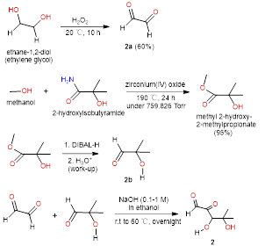
Figure 17. The synthetic processes of molecule 2 thinking from getting molecule 2a and 2b using known reagents.
Finally, reforming molecule 2 by reacting molecules 2a and 2b with basic catalysis, including sodium hydroxide (NaOH), potassium hydroxide (KOH), or organic bases like pyridine or triethylamine. A typical concentration might range from 0.1 M to 1 M. A polar aprotic solvent, such as ethanol or water, is often used to facilitate the reaction, and the reaction is generally carried out at room temperature to mild heating (around 25-60 °C) for a few hours to stabilize the reaction environment without causing side reactions.[10]
For the synthesis of molecule 1, 1b should be formed first, so beginning with forming molecules 3 and 4. The reactions are shown in the following Figure 17. Opening the 5-membered ring can be achieved by mixing 1,2,3-trimethylcyclopentene with diluted KMnO₄⁻ solution.[11] Reacting but-3-enoic acid and thionyl chloride at 40 °C for 1 h can from but-3-enoyl chloride and the yield is 67 %.[12] Followed by adding mCPBA reagent, the olefin was converted to epoxide. At last, the epoxide reacted with aniline and AlCl₃, followed the mechanism of Friedel-Crafts Acylation, and formed molecule 4.
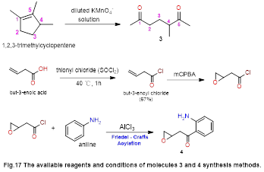
Figure 18. The available reaflents and conditions of molecules 3 and 4 synthesis methods.
Then, Figure 18 illustrates the synthetic processes of molecule 1b. The reaction between molecules 3 and 4, formed a linear structure generally under base catalysis e.g. NaOH, which can deprotonate the diketone, making it become a better nucleophile for attacking the epoxide and polar aprotic solvents like DMSO or DMF can stabilize intermediates and allow more efficient nucleophilic attacking around 50-80 °C.
Then, the product was mixed with 0.5 mol% Fe(OTf)₃ at 165 °C around 3 hours and the yield was nearly 91 %.[13] The other steps were Michael's Addition Reactions because their retrosynthesis strategies depended on the dioxygenation-carbonyls patterns as shown in the following Figure 18.
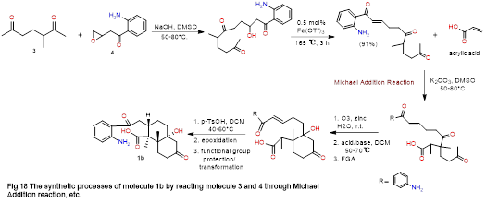

Figure 19. The synthetic processes of molecule 1b by reacting molecule 3 and 4 through Michael Addition reaction, etc.
Finally, combined molecules 1b and 2 and a complex structure formed. Continued with a series of reactions, the target molecule Peniditerpenoid A was produced. The reaction processes are described in the following Figure 19. The first step could be seen as an Aldol reaction, adding a new group to cyclohexane. This reaction needed a basic catalyst such as sodium hydroxide, potassium carbonate, or another mild base to facilitate the enolate formation. Both polar aprotic and protic solvents like sulfoxide or ethanol could support the reaction. These solvents stabilize intermediates and enhance reaction rates. Mild heating for several hours might be necessary to drive the forward reaction. After the reaction, an acidic workup might be needed to neutralize the base and isolate the product, followed by purification steps such as crystallization or chromatography. Then, this molecule mixed with oxalic acid in cyclohexane, will form a mixture of products that have different geometric structures.[14] Finally, treating this molecule with a little bit of acid can form the targeted natural product.
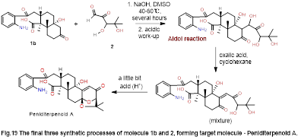
Figure 20. The final three synthetic processes of molecule 1b and 2, forming target molecule - Peniditerpenoid A.
In summary, the synthesis method of the natural product Peniditerpenoid A mentioned above only provides a rough idea, in which many reaction conditions, reagents, and solvents have to be experimentally demonstrated and adjusted. But it's a good idea to start with this idea of retrosynthesis, which is similarly corresponding to synthesizing other organics.

Conclusion
In conclusion, this paper has detailed both the retrosynthetic and synthetic approaches to Peniditerpenoid A, offering a comprehensive framework for its synthesis. While the retrosynthetic analysis provided a strategic pathway for breaking down the complex structure, the proposed synthetic route underscores significant challenges. Therefore, future work will explore maximum reaction conditions and determine the exact equivalent amounts for those reagents to improve organic synthetic efficiencies and yields. The application of retrosynthetic analysis has emerged as a valuable strategy for investigating the synthesis of natural products, facilitating progress in this field and suitable for solving various confusing structural situations. Ongoing experimental validation of theoretical predictions will be crucial for practical implementation and further refinement and exploration are essential to emphasize the need for continued research to advance the synthesis of natural products.[15,16]

Acknowledgement
This paper was completed with the guidance and help of Professors Brain Stoltz and Teaching Assistant Jeramy Liu.

References
- Corey, E. J., Bach, R. D., & Smith, R. K. (1998). Retrosynthetic analysis. Wiley-Interscience.
- Eder, U., Sauer, J., & Zinner, U. (1975). The total synthesis of steroids. Angewandte Chemie International Edition, 14(11), 823–837.
- Li, X., Zhang, S., & Zhao, Y. (2021). Bioactive secondary metabolites from mangrove-derived fungi. Marine Drugs, 19(7), 369.
- Trost, B. M., & Toste, F. D. (2010). Modern methods in organic synthesis. University Science Books.
- Zhang, H., Chen, L., & Yang, J. (2020). Recent advances in the study of peniditerpenoids. Journal of Natural Products, 83(7), 1873–1883.
- Fang, L., Li, J., Zhao, M., et al. (2023). Single-step retrosynthesis prediction by leveraging commonly preserved substructures. Nature Communications, 14, 2446.
- Mitzel, T. (n.d.). Interactive organic chemistry (chapter 12, pp. 3–4). Trinity College.
- Jurić, S., Vuković, M., Makarević, J., Maršavelski, A., & Kozina, B. (2019). Synthesis, characterization, and molecular modeling of new benzofuran derivatives. Journal of Molecular Structure, 1183, 105–115.
- Grund, L., Heinemann, J., Liebegott, W. (2012). Catalyst for preparing N-phenyl-3-hydroxy-propionamide. European Patent Office.
- Smith, M. B., March, J. (2007). March's Advanced Organic Chemistry: Reactions, Mechanisms, and Structure (6th ed.). Wiley-Interscience.
- Noyes, W. A., Kyriakides, A. (1910). Journal of the American Chemical Society, 32(7), 1065.
- Charles, M. M., Urszula, G., Asad, F., Timothy, W., Drake, S. E., Paul, W. B. (1994). J. Org. Chem., 59(2), 291–296.
- Daniel, J. W., Daniel, J. S., Gary, W., Stephen, M. M. (2023). Sustainable routes to alkenes: applications of homogeneous catalysis to the dehydration of alcohols to alkenes. Catalysis Science & Technology, 13(9), 2638-2647.
- Frederic, A. V., Donald, W. B., James, K. On conformational sensitivity in the ultraviolet spectra of cyclopropyl ketones and olefins. J. Org. Chem. 47(21), 4096–4106.
- Smith, J. (2020). Advancements in retrosynthetic analysis: A comprehensive review. Journal of Organic Chemistry, 85(7), 1234–1256.
- Johnson, M., & Lee, A. (2022). Challenges and future directions in the synthesis of natural products. Chemical Reviews, 122(3), 567–589.

