Chemical total synthesis of a compound found in fugus Rhizopus sp. W23: Norcyclocitrinoic acid A
Xing Liu
The University of Hong Kong, Pok Fu Lam, Hong Kong, China
U3583497@connect.hku.hk
Abstract. The diversity of marine microorganisms and fungi has led to various chemical extracts, some of which have specific medicinal values. Norcyclocitrinoic acid A extracted from the deep-sea fungus Rhizopus sp. W23 has a unique tetracyclic steroid structure, which makes it possible to have anti-osteoporotic activity. This article opens up a whole new way of thinking about the pure chemical synthesis of Norcyclocitrinoic acid A. A very detailed synthetic pathway is explained in this article. In addition, a sugar-like structure and a Vitamin C-like structure were found in the synthesis, providing a basic idea for the future synthesis of more fungal extracts. Furthermore, the article suggests many directions for further research and experimentation.
Keywords: Deep Sea fungus, Rhizopus sp. W23, Norcyclocitrinoic acid A, Total synthesis, Proposal of synthesis, Bicyclic [4.4.1] ring system, Retrosynthesis, tetracyclic steroid

Introduction
Microorganisms are an essential source of biologically active substances in nature, and the oceans are rich in microorganisms and fungi [1], many of which are characterized by specific chemicals. To a certain extent, these special chemicals can be used in the pharmaceutical industry, and the compounds extracted from the deep-sea fungus Rhizopus sp. W23 has a very complex architecture [2], such as tetracyclic steroid containing a bicyclic [4.4.1] ring system, etc, have attracted significant attention. The background of Rhizopus sp. W23 extract dates back to 2000. In a paper published by Kozlovsky in 2000 [3], this similar substance was first identified from the terrestrial fungus Penicillium citrinum and was thought to possess 7/5 -5/5 tetracyclic. However, in 2003, Amagata and his team demonstrated for the first time that it has a 7/7/6/5ring ring structure by X-ray crystallographic analysis [4]. Finally, thanks to the efforts of He and his team, 19 structures of fungus Rhizopus sp. W23 extracts were published in 2023 [5]. The latest discovery and publication of seven structures, including Norcyclocitrinoic acid A, has been published. In another article by He 2023, there was a reference to some manifestations of Neotricitrinol B (2), i.e., the possibility that Neotricitrinol B (2) exhibits anti-osteoporotic activity, and through more in-depth discovery, this tetracyclic steroid possesses potential anti-osteoporotic activity. Similarly, seven tetracyclic steroid-containing compounds were found in the deep-sea fungus Rhizopus sp. W23, this tetracyclic steroid containing a bicyclic [4.4.1] ring system, is well worth investigating, and the most noteworthy are the 19 structures of compounds extracted from the deep-sea fungus Rhizopus sp. W23 is the most recently updated one. The first compound, also known as Norcyclocitrinoic acid A, is shown in Figure 1. This paper will provide ideas for the synthesis of Norcyclocitrinoic acid A by pure chemical synthesis.
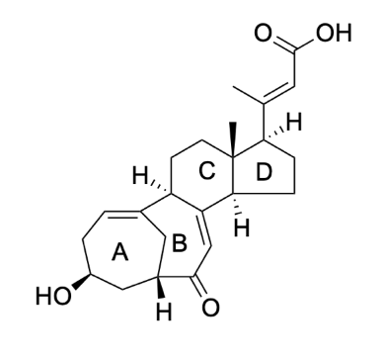
Figure 1. Structure demonstration of the compound Nnorcyclocitrinoic acid A
Figure 1 visualizes that the compound Norcyclocitrinoic acid A has four rings named ring A-D. Ring A is a seven-member ring with a pointing out hydroxyl group, and it is worth noting that there is a double bond on top of ring A. The ring A has a double bond, and the ring A has a double bond. It is noteworthy that there is a double bond on top of ring A. Ring B shares three carbons with ring A and forms another seven-member ring, which also carries two functional groups, a ketone at the bottom and a double bond close to it. Ring C is connected to ring B, a standard six-member ring. Ring C is connected to ring B, a normal six-member ring with a pointing out methane above the junction with ring D. Ring D is a five-member ring with a small chain carboxylic acid group. Furthermore, there is a double bond near the carboxylic acid group on the small chain. Whereas there are many cut points for the whole compound, it is more important to cut the four rings in an orderly [6], so the cuts of ring A-D are considered first.
In the retrosynthesis, the two rings that can be used as center cuts in the compound Norcyclocitrinoic acid A are ring B and ring C. Cutting ring C will lead to two relatively homogeneous compounds, but there are better solutions. However, there are better solutions than this because splitting rings C, A, and B, which are linked to double seven-member rings, will form a relatively complex compound. In addition, the complex double heptacyclic compound has four functional gourds, which is not an easy and reasonable target molecule. Therefore, disassembling ring B would be a more appropriate and reasonable choice.
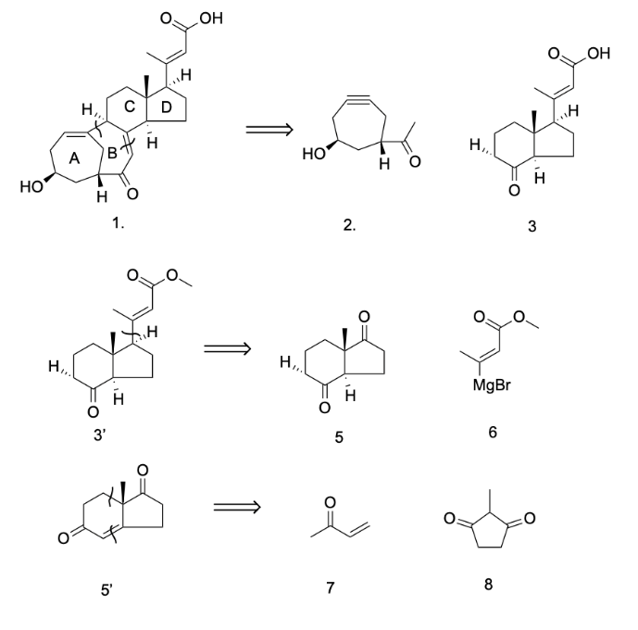
Figure 2. Schematic diagram of retrosynthesis of Nnorcyclocitrinoic acid A
Figure 2 shows the steps of Retrosynthesis, which also cleaves ring B and further cleaves complex chemicals. In compound 1, single and double bonds on ring B are broken to form compounds 2 and 3. Compound 2 is a less stable intermediate because it carries a triple bond within the ring. Moreover, the double bond on cleave ring B is because it is near a ketone group, and this feature makes it possible for it to be used as an intermediate. Compound 2 is a less stable intermediate because it carries a triple bond within the ring, while the double bond on cleave ring B is due to its proximity to a ketone group. This feature makes it possible to consider the reaction of a double on ketone. In addition, the relatively complex compound 3 will be further disassembled, and some Retrosynthesis will be done. Compound 3' differs from compound 3 only because the carboxylic acid group has been replaced with an ester. This is because the format reagent for the format reaction is a primary reagent [7], which is incompatible with the acidic carboxylic acid group functional group. Therefore, compound 3' was replaced with a neutral ester group to accomplish the format reaction better. For compound 3', his retrosynthesis is a format reaction that combines compound 5 and compound 6 through a format. Compound 5 is still a complex chemical, a 6, 5 ring containing two ketones. Therefore, a further cleave bond is preferred. In this case, compound 5 differs from compound 5 in the ketone position on the six-member ring and the extra double bond. Since the two ketones on compound 5 meet between the two carbons, if the compound is simplified, this would be a 1,4 ketone, and this compound is challenging to form. Thus, subsequent methods can reduce compound 5, the extra double bond and the final starting material is compound 7 and 8.
Compound 7 and compound 8 are commonly used in daily experiments and have been industrialized. Compound 7 is called Methyl vinyl ketone, a relatively high toxicity and corrosive compound. The SDS report shows that Methyl vinyl ketone is an explosive compound with high toxicity and corrosiveness, which is not very suitable for chemical experiments from the point of view of green chemistry [8]. Therefore, researchers need to be careful and pay attention to the use of this compound at all times. On the other hand, compound 8 is a relatively milder compound called 2-Methyl-1,3-cyclopentanedione, which is also corrosive but relatively mild, so to a certain extent, it is in line with green chemistry.

Results and discussion

Total synthesis of compound 2
The total synthesis can be divided into two parts using retrosynthesis, which is compound disassembly. The first part is the synthesis of compound 2 in Figure 2, i.e., a seven-member ring with a triple bond. In contrast, the second part is the relatively responsible compound 3, and Retrosynthesis can also provide a general idea for the total synthesis. The second part is the relatively responsible compound 3. The complete total synthesis is shown in Figure 3, which includes the reaction conditions, the product after the reaction, and the reaction path.
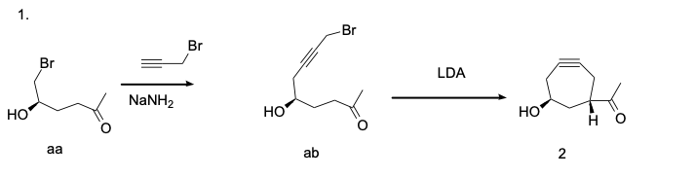
Figure 3. The total synthesis of compound 2
Shown from left to right in Figure 3 is a total synthesis of compound 2, where the compound ab is synthesized via a triple bond and NaNH2 conditions. Adding propargyl bromide to compound aa will connect the triple bond to compound aa without affecting the triple bond and form compound ab and HBr. In the presence of LDA, Br will be removed from compound ab and connected to the alpha-position to form a seven-position. The position is to form either a seven-member or nine-member ring, but the more stable seven-member ring, compound 2, will be the major product. A novel type II intramolecular [5+2] cycloaddition can also synthesize seven-member rings [9].

Total synthesis of compound 3 main synthesis
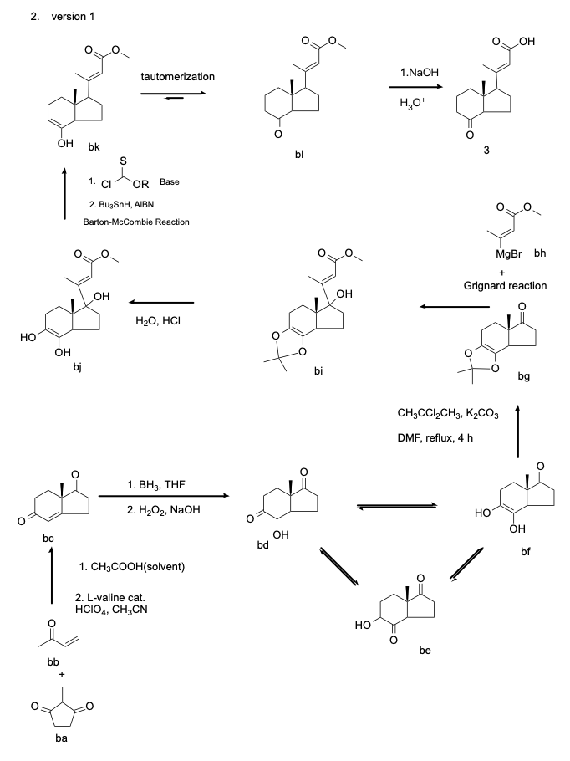
Figure 4. The main total synthesis of compound 3
The whole synthesis path in Figure 4 starts with compound ba and compound bb synthesis at the bottom. In the synthesis of compound bc, the alpha position in compound ba plays a significant role. Compound ba and compound bb were synthesized by a conventional Robinson reaction with HClO₄, CH₃CN, under the L-valine catalyst condition, in addition to the addition of CH₃COOH as a solvent can complete a whole Robinson reaction [10]. Immediately following the BH3 and THF conditions, adding H₂O₂ and NaOH as a second condition adds a hydroxyl group to the double bond in compound bc. The major product in this condition will be compound bd [11] as the hydroxyl group will be added to the double bond in this condition. The hydroxyl group would be added to the secondary carbon rather than the tertiary carbon. However, after adding the hydroxyl group, compound bd is not a stable compound. Since ketone and hydroxyl groups are nearby, it is very similar to sugar compounds and will form a resonance in the middle, forming an aldose-ketose compound [12]. Aldose-ketose yield can be controlled in disguise by controlling a certain amount of aluminum oxide [12]. However, this is a special aldose-ketose resonance compound. Since it exists in a ring, it will be more similar to vitamin C [13], so it is speculated that most of this aldose-ketose resonance compound will end up stabilized in the compound bf. For better doing the format reaction, the bf, similar to the vitamin C structure, will undergo some treatment and protection.
For four hours, heat under reflex in CH₃CCl₂CH₃, K₂CO₃, and DMF will give compound bg. Formatting compound bg with compound bh will give complex compound bi, and the excess hydroxyl group will appear above the five-membered ring. Ring above. Afterward, the reduction of compound bi to compound bj is carried out by the condition’s H₂O and HCl, in which the reaction of bi to ester group may also be carried out to the carboxylic acid group, and even if the carboxylic acid group is formed, the whole reaction can be continued. After this, the Barton-McCombie reaction will remove the additional unwanted hydroxyl group [14]. The first hydroxyl group that this reaction will remove is the hydroxyl group that remains on the five-member ring after the format reaction. Secondly, most of the hydroxyl group located on the opposite side of the large compound in the six-member ring will be removed to form the short-lived intermediate compound BK. The compound bk will undergo rapid keto-enol tautomerization [15] and eventually be stabilized in the compound bl. Finally, the ester group that fails to participate in the reaction can be reduced to the carboxylic acid group by NaOH and H₃O⁺ to give compound 3.
The synthetic feasibility and efficiency of the main total synthesis are very high, except for some particular reactions that require control of the catalyst or environment. The only thing worth noting is that the resonance of aldose-ketose compounds in the middle of compound bc to compound bg in the whole main total synthesis is a vast topic that needs experimental authentication to come up with the exact answer. Thus, an avoid aldose-ketose compounds resonance method was proposed, as shown in Figure 5.

Total synthesis of compound 3 addition synthesis
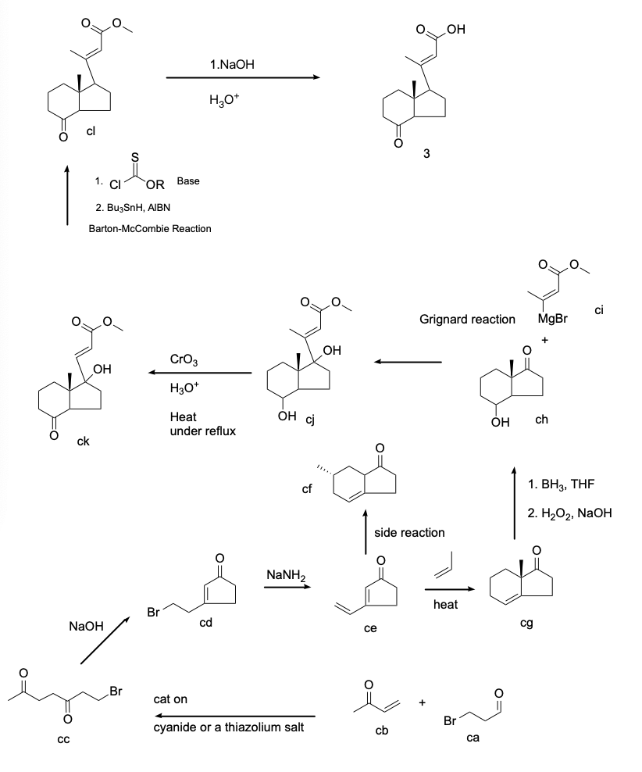
Figure 5. The additional total synthesis of compound 3
In Figure 5, the synthesis of compound ch to compound 3 is very similar to the main total synthesis of compound bg to compound 3 in Figure 4. Instead, the focus of Figure 5 is on the use of the avoid aldose-ketose resonance via the Diels Alder reaction. In the addition reaction, the starting material becomes compound cb and compound ca, and the synthesis of 1, 4-diketone can be completed by forming compound cc with cyanide or thiazolium salt as the catalyst. Then, a five-member ring was formed by NaOH to form compound cd, and bromine was reduced to a double bond by NaNH₂ to form compound ce. The 1,4 double bond of the Diels-Alder reaction [14] was completed. The addition of a dienophile, which is propylene, will form a six-member ring, and the subsequent synthesis will result in compound 3. However, the Diels Alder reaction will result in the formation of a side product, compound cf.
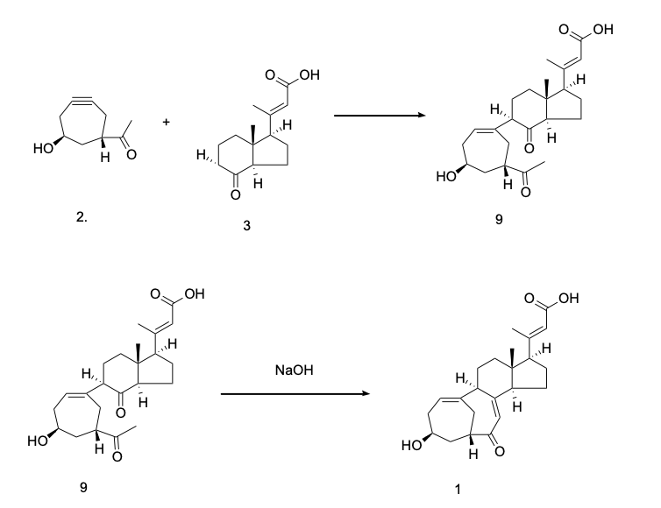
Figure 6. The total synthesis of Nnorcyclocitrinoic acid
Finally, in Figure 6, the synthesis of the final product, Norcyclocitrinoic acid A as the target product, is shown, synthesized from compound 2 and compound 3. When formatting compound 2 and compound 3, the unstable triple bond in compound 2 will be the first to connect with the alpha position in compound 3. However, the triple bond of compound 2 has two positions to choose to connect, so there is a chance to get compound 9 here, and the final yield needs to be obtained by experimental methods. Compound 9 will undergo a unique Robinson reaction in the presence of NaOH to link the ketone to the alpha-position carbon underneath, and there will be a chance to get compound 1, Norcyclocitrinoic acid A.

Evaluation
The proposal includes very detailed ideas about inverse synthesis and total synthesis. However, there are still some limitations in the proposal; the first one is the limitation of the synthesis proposal; as a proposal, it does not have any experimental data and conclusion, so most of the results are from the information. Therefore, in order to further improve the synthesis, more experimental conclusions should be used. The experimental findings can be used to refine and improve the chemical synthesis. Secondly, more limitations come from the final synthesis in Figure 6, which could be more stable. Due to the instability of the triple bond and its high susceptibility to reaction, the final yield of compound 9 cannot be determined, and this topic can be explored in depth.
In addition to this, many other topics could have been discussed in more depth throughout the proposal. Firstly, a new type II intramolecular [5+2] cycloaddition could be used to synthesize seven-member rings. Furthermore, the aldose-ketose resonance, which is structurally similar to that of Vitamin C, is also a critical topic, and through more in-depth experiments and studies on this crucial component, another approach to synthesizing fungal extracts can be developed. The synthesis of fungal extracts could be expanded through more in-depth experimentation and study of this crucial component. The structural, product, and yield control studies will allow for a deeper understanding of Vitamin C and, at the same time, allow for the control of the aldose-ketose resonance.

Conclusion
This paper presents a novel synthetic idea for Norcyclocitrinoic acid A, centered on the complete severance of the B ring as the basis. In addition, two different synthetic schemes are provided in the paper for synthesizing compound 3. One of the critical total synthesis schemes involves the characterization of crucial sugars and vitamin C, a synthetic direction worth exploring. In the synthesis of compound 1, a novel seven-membered ring synthesis is suggested.
Further, additional information and research directions are presented in the article's evaluation section and the middle. These directions include the controlled aldose-ketose resonance for structural similarity of vitamin C, a novel type II intramolecular [5+2] cycloaddition reaction for the synthesis of seven-membered rings, the synthesis of unstable ternary rings, and directions for the study of unstable triple bonds, as well as a substitution method using the Diels-Alder reaction. By analyzing these positive studies in depth, the synthetic pathway of Norcyclocitrinoic acid A will become clearer, which will drive the development of synthetic techniques for compounds related to fungal extracts.
In this way, the article demonstrates synthetic strategies based on innovative thinking and extends the boundaries of current chemical synthesis by proposing new types of chemical reactions and synthetic routes. Exploring these synthetic routes will help achieve more efficient and specific synthetic methods. However, it may also reveal new chemical reaction mechanisms and provide new perspectives and tools for future drug discovery and chemical research.

References
- Davidson, B. S. (1995). New dimensions in natural products research: cultured marine microorganisms. Current Opinion in Biotechnology, 6(3), 284-291.
- He, Z. H., Xie, C. L., Wu, T., Yue, Y. T., Wang, C. F., Xu, L., ... & Yang, X. W. (2022). Tetracyclic steroids bearing a bicyclo [4.4. 1] ring system as potent antiosteoporosis agents from the deep-sea-derived fungus Rhizopus sp. W23. Journal of Natural Products, 86(1), 157-165.
- Kozlovsky, A. G.; Zhelifonova, V. P.; Ozerskaya, S. M.; Vinokurova, N. G.; Adanin, V. M.; Grafe, U. Pharmazie 2000, 55, 470−471.
- Amagata, T.; Amagata, A.; Tenney, K.; Valeriote, F. A.; Lobkovsky, E.; Clardy, J.; Crews, P. Org. Lett. 2003, 5, 4393−4396.
- He, Z. H., Xie, C. L., Wu, T., Zhang, Y., Zou, Z. B., Xie, M. M., ... & Yang, X. W. (2023). Neotricitrinols A–C, unprecedented citrinin trimers with anti-osteoporosis activity from the deep-sea-derived Penicillium citrinum W23. Bioorganic Chemistry, 139, 106756.
- Šunjić, V., & Peroković, V. P. (2016). Organic chemistry from retrosynthesis to asymmetric synthesis. Springer.
- Westerhausen, M., Koch, A., Görls, H., & Krieck, S. (2017). Heavy Grignard reagents: synthesis, physical and structural properties, chemical behavior, and reactivity. Chemistry–A European Journal, 23(7), 1456-1483.
- Anastas, P., & Eghbali, N. (2010). Green chemistry: principles and practice. Chemical Society Reviews, 39(1), 301-312.
- Li Q, Jiang GJ, Jiao L, Yu ZX. Reaction of alpha-ene-vinylcyclopropanes: type II intramolecular [5+2] cycloaddition or [3+2] cycloaddition? Org Lett. 2010 Mar 19;12(6):1332-5. doi: 10.1021/ol100237h. PMID: 20192198.
- Gawley, R. E. (1976). The Robinson annelation and related reactions. Synthesis, 1976(12), 777-794.
- Brown, H. C., & Sharp, R. L. (1966). Hydroboration. XXIV. Directive Effects in the Hydroboration of Some Substituted Styrenes1. Journal of the American Chemical Society, 88(24), 5851-5854.
- Ekeberg, D., Morgenlie, S., & Stenstrøm, Y. (2007). Aldose–ketose interconversion in pyridine in the presence of aluminium oxide. Carbohydrate research, 342(14), 1992-1997.
- Padayatty, S. J., & Levine, M. (2016). Vitamin C: the known and the unknown and Goldilocks. Oral diseases, 22(6), 463-493.
- McCombie, S. W., Motherwell, W. B., & Tozer, M. J. (2004). The Barton‐McCombie Reaction. Organic Reactions, 77, 161-432.
- Lee, D., Kim, C. K., Lee, B. S., Lee, I., & Lee, B. C. (1997). A theoretical study on keto‐enol tautomerization involving simple carbonyl derivatives. Journal of computational chemistry, 18(1), 56-69.
- Nicolaou, K. C., Snyder, S. A., Montagnon, T., & Vassilikogiannakis, G. (2002). The Diels–Alder reaction in total synthesis. Angewandte Chemie International Edition, 41(10), 1668-1698.

