EXPLAINABLE HYBRID DEEP LEARNING APPROACH FOR OKRA (LADY’S FINGER) LEAF DISEASE DETECTION USING CBAM-ENHANCED RESNET ARCHITECTURES

Ms R. Renuga devi,

Assistant Professor (Sr.G),

Dept of Computer Science,
KIT-KalaignarKarunanidhi
Institute of Technology (Autonomous),
renugadevime@gmail.com .
Dr .S. Santhi
Professor,
Dept of Computer Science,
KIT-KalaignarKarunanidhi
Institute of Technology (Autonomous), ssanthi.kit@gmail.com

Mr. M. Mohanasundharam
Assistant Professor,
Dept of Computer Science,
Hindusthan College of Engineering & Technology
mohantvsm@gmail.com

Ms. M. Amuthavalli,
Assistant Professor,
Dept of Computer Science,
Hindusthan College of Engineering & Technology
amuthakucs@gmail.com

Abstract -- It is possible that the entire crop may be destroyed, secretly, and unnoticed before the farmer even becomes aware of the damage inflicted, especially concerning okra (lady's fingers). The slight infection which is developed on leaves gets aggravated very rapidly causing reduction in the yield and quality. The plant becomes a prey to the diseases. Tiny spots of the infection developed on the leaves, while don't appear to be deadly, do ultimately reduce the saleability of the plant,slow down growth of the plant, and bring down yield. Existing disease identification approach relies on manually observing it which are too time-consuming, lack consistency and produce inconsistent conclusion results. This suggests to develop hybrid deep learning model which could diagnose okra leaf diseases based on ResNet50 and ResNet101 models. Instead of using one of the two models performing classification, the hybrid model will capture deep level information from the image through two different layers. Initially, the okra leaf images are cleared and pre-processed so the system only focuses on the pattern of disease. Feature extraction will occur by feeding the input image to ResNet50 and ResNet101 models parallelly. These two feature vectors were merged through some simple hybrid technique where the two different viewpoints were taken into account before outputting the classification result. After merging the two, the entirely merged dropped network layer would take care of classifying these multiple classes of diseases. The main motive behind this architecture is to make a balanced model out of the two systems. ResNet50 is efficient computationally but it also makes good sense of visual feature and at same time, ResNet101 captures more in-depth and efficient feature. Combines two system to bring a more powerful one. The final model then can be validated on multi class plant disease data set to classify and to test its accuracy, on various class of diseases and later evaluate the overall performance on other important metrics as well. The final performance revealed both enhancement in the classification performance and greater robustness & better interpretability. The visualization of the part of the leaf where the model is capable of identifying the disease symptom can also be represented with technique like Grad-CAM as it benefits even the human expert for interpretation. In the end, this framework produces an efficient and trustworthy system for identifying the disease that combines explainable AI concept to help farmers more in the real agriculture setting.

Keywords- Okra Leaf Disease Detection, ResNet50, ResNet101, CBAM, Hybrid Net, Transfer Learning, Grad-Cam, Deep Learning, ResNet Architecture.
- INTRODUCTION
Farmers primarily make their living through growing okra. This is because okra (lady's fingers) is a valuable vegetable in terms of its nutritional value and commercial demand and is widely grown in our region. However, okra plants are prone to various diseases which can affect both their growth and yield. After the disease has set in, the plants continue to weaken, causing yield and quality to deteriorate. Farmers might notice colour changes or abnormal textures, but these issues often become untreatable before they are detected. Thus, early detection is crucial, as even subtle signs could lead to complete loss. Manual inspection, a traditional method, can be prone to human error; different diseases may also present similarly, and early symptoms can easily be missed.
More recently, artificial intelligence and deep learning techniques have been applied to this problem, offering faster and more consistent analysis than manual methods, though they still have limitations and are not always perfect. Among the various deep learning models available, convolutional neural networks (CNNs) excel at image classification, learning directly from image textures rather than through manual analysis. Essentially, with increased training, CNNs become adept at identifying shapes, textures, colour variations, and disease-specific patterns.Numerous CNN architectures have been successfully utilised for plant leaf disease detection, each with its own advantages. Some models are more computationally efficient, while others are more suitable for real-time applications. The optimal choice depends on factors such as accuracy, computational resources, and dataset complexity.Compared to traditional approaches, new methods offer improved performance. Our study focused on okra leaf disease detection using a combination of ResNet50 and ResNet101 models to leverage their combined strengths. While many CNNs are useful, some may not fully utilise the spatial and channel-wise attention mechanisms that are essential for detecting subtle disease-related features.Our system employs a hybrid deep learning framework for detecting okra leaf diseases, combining ResNet50 and ResNet101 with the Convolutional Block Attention module (CBAM). CBAM enhances feature representation by prioritising important spatial and channel information, thus improving the network's discriminative ability. Features from both networks are combined through a simple join operation and then fed into dense layers for classification. This hybrid design allows the system to classify with greater accuracy, handle complex cases more effectively, and adapt to new challenges by integrating deep-layer knowledge with focused features. Our model was evaluated using standard performance metrics such as accuracy, precision, recall, and F1-score, based on a dataset of okra leaf diseases. Our novel hybrid model outperformed existing CNN-based models in classification performance. Additionally, we incorporated Explainable Artificial Intelligence (XAI) techniques, such as Grad-CAM, to visualise the diseased areas, making the model more transparent and trustworthy.
We proposed a new hybrid framework by integrating ResNet50, ResNet101, and CBAM. This framework not only addresses the limitation of manual detection and a single deep learning model but also provides a more powerful backbone network. Two different models learn different patterns from a single image, which significantly improves the plant disease detection. The hybrid model used two different networks, ResNet50 and ResNet101, in the framework, which work together to learn features on mid-level and deep-level images, respectively; that is, ResNet50 helps to learn the visual patterns on okra leaf images, and ResNet101 helps to extract the detailed features. CBAM helps in making the system intelligent to concentrate more on the important disease-affected areas while diminishing the less important information present in the background by focusing on key spatial and channel information; thus, it helps to increase feature quality and strengthen the classification accuracy. A visualization technique named Grad-CAM was also implemented in the framework.
Overall, our proposed framework offers a robust method for detecting okra leaf diseases. It leverages deep feature learning and attention mechanisms, making it a valuable tool for agricultural applications.
- LITERATURE SURVEY

Zaichun Yang [1] proposed a new method to detect diseases on tomato leaves by merging image information with expert knowledge and some cool techniques such as MLCFA, ALDP, and PISC loss to increase the accuracy of detection. However, the proposed method fails to generalize when extreme conditions exist and does not exploit the supplementary information like time and light wavelengths for the actual usage in real fields.
In order to tackle these issues, the proposed research aims to present a new method for detecting okra leaf diseases using ResNet50 and ResNet101 enhanced by CBAM and Grad-CAM. The dual-backbone structure extracts complementary features, while CBAM helps focus on regions essential to identify the diseases for robust field utilization in various field scenarios. Compared to MSLCFNet, our proposed method has the capability of improving generalization without using inputs from multiple sources. Grad-CAM additionally aids in highlighting where the disease is located for a greater understanding and confidence in the method among farmers to be used in real farming environments.
Yali Bai [2] has suggested a hyperspectral-based approach to detect the maize leaf spot disease based on temporal response analysis and spectral characteristics. This method extracts information that is crucial to tree canopies, like area, rate, and efficiency of photosynthesis, and utilizes the correlation of both physical and spectral light information for accurate detection at various infection stages. On the other hand, this method is not very beneficial for the detection of different types of maize leaf diseases like rust, blight, and anthracnose. It is also subject to problems due to uncertainty introduced by mismatching field and satellite data and its dependence on subjective diagnoses, which reduces credibility in the detection of disease symptoms and indicates the necessity for an automated and generalized solution.
In order to overcome the above problems, the proposed research aims to present a new method to detect okra leaf diseases using ResNet50 and ResNet101 enhanced by CBAM and Grad-CAM. Instead of using expensive hyperspectral and remote sensing data, the proposed hybrid CNN-based model only takes images with regular RGB values as an input; thus, it is practical and scalable for various fields. CBAM will greatly improve the feature extraction performance, and it can better adapt to various field scenarios. Combined with two backbone structures, it can make the model more robust. Grad-CAM visualizes the detection area clearly, which will greatly reduce the human subjective diagnosis and enhance the usability for rapid, economical, and fully automatic farming systems.
Zidi Wu [3] has presented EPDNet for the recognition of single-modal tomato leaf diseases in outdoor settings with unbalanced and complex datasets. EPDNet combines the EPFEM attention mechanism, the PHLF hybrid loss function, and the DAOA optimization algorithm to achieve better feature extraction, remove the background noise, and enhance classification accuracy and robustness. However, EPDNet has limitations in discriminating early and late stages of the same diseases like blight because it works with one single image without exploring its temporal variation.
In order to overcome the limitations, the proposed research aims to present a new method for detecting okra leaf diseases using ResNet50 and ResNet101 enhanced by CBAM and Grad-CAM. The dual-backbone network extracts both spatial and semantic features, whereas the CBAM helps to increase the attention to the feature maps of important regions of the disease, thereby enhancing the accuracy of differentiating similar stages. Our proposed method overcomes EPDNet by enhancing feature representation without incorporating the time dimension and sequence information to adapt to on-site farming scenarios. Grad-CAM further assists in visualizing disease areas, which reduces subjectivity in the method for more reliable and open disease detection in farming.
Poonam Ray's [4] study presented a simple and low-cost liquid-based spray inoculation method using an air spray device for uniform spraying on the pea leaves. The disease gauge detection based on the image analysis was done through the free software, so less technical knowledge is needed for operation while yielding moderate consistency compared to high-end systems.
In order to tackle these problems, the proposed research aims to present a new method to detect okra leaf diseases using ResNet50 and ResNet101 enhanced by CBAM and Grad-CAM. The new method goes beyond the outdated manual checks and post-processing by leveraging automatic deep learning for immediate disease detection. The dual-backbone structure strengthens the feature extraction process, while CBAM refines the model's focus on diseased regions, making it more resilient to variations in outdoor environments. Grad-CAM highlights the infected areas, removing reliance on manual observations, thus creating a more efficient and adaptable system for real-time farming.
K M Fazlul Kobir Siam [5] studied the collection of images for the diagnosis of lemon leaf disease and introduced extra images for nine types of disease detection, thereby increasing the accuracy of detecting the diseased part. An image classification DenseNet-121 model was trained using this dataset, and the result showed significant classification performance that could assist farmers in identifying the disease at its early stage for lemon trees. But the study was conducted by using a geographically limited dataset, which reduces its effectiveness in other regions. The problems faced in the method are the class imbalance problem, the narrow view range of the images due to only one camera source, and the absence of latent symptoms
In order to tackle these problems, the proposed research aims to present a new method to detect okra leaf diseases using ResNet50 and ResNet101 enhanced by CBAM and Grad-CAM. The proposed system is designed to effectively learn robust features using two different deep learning networks collaborating together to extract various visual features. CBAM will increase focus on the key disease features, which may result in robustness to various field scenarios and noise that can be seen due to differences in datasets. Grad-CAM is designed to demonstrate an explanation for what prediction it made, thus enhancing the explainability. This means that the proposed method can be used in a real farming system.
James Daniel Omaye's [6] study surveyed various machine learning models used in diagnosing and treating plant diseases under several crops and several types of disease and mentioned the importance of various factors like age, stages of disease, field and farming environment, and treatments that might improve prediction accuracy of plant diseases and monitoring and diagnosis accuracy. However, the survey limited its search based on the search query words, which could miss the articles available at non-accessible sources.
In order to tackle these problems, the proposed research aims to present a new method to detect okra leaf diseases using ResNet50 and ResNet101 enhanced by CBAM and Grad-CAM. This is a practical deep learning method that enables direct learning of what disease features need to be recognized in the actual photographs. The dual-backbone structure enables feature representation more powerfully; CBAM focuses on disease-related regions of images for robust field application. Grad-CAM reveals which parts contribute to the detection process that enhances explainability and farming utilization.
Sachin Dahiya [7] In this paper they had tested a few different parameters for getting optimum settings in order to find the disease present in the plant village data and for deep learning models. They found out that ResNet50 and ResNet101 were successful when they had trained them with 25 epochs, a low learning rate of 0.0001, and the Adam optimizer. But this only tests Plant Village data, and that data is the image of a leaf obtained under controlled conditions and is not the real-world leaf images that would be found out in the fields. AlexNet and SqueezeNet, lighter deep learning models, performed worse than deeper ones.With these drawbacks, the suggested work focuses on proposing an advanced technique to detect okra leaf diseases by using ResNet50 and ResNet101 combined with CBAM and Grad-CAM. The model developed has been designed to work on real-time images where lighting, background, and disease appear different from images in the lab, unlike most studies that use data sets tested in the laboratory. The dual-backbone architecture captures features at mid and deep levels, while CBAM improves the attention to details required to detect disease, thus making the detection more effective. Moreover, Grad-CAM explains the predictions in the form of visuals, making it very transparent and hence useful for real-time farming applications.
Naveena S [8] The authors focused on developing Ensemble Net to classify the diseases in cotton leaves by combining multi-scale feature extraction and shape-based CNN and non-local CNN. The architecture integrates the outcome of various modules, which results in an effective leaf disease classification with reduced overfitting. But Ensemble Net is unable to distinguish between diseases like bacterial blight and Cercospora leaf spot due to their visually similar appearance and fails to correctly identify healthy leaves due to data imbalance. So it is not a robust enough system.
So, with these drawbacks, the proposed system presents an ultimate solution for detecting okra leaf diseases by using ResNet50 and ResNet101 combined with CBAM and Grad-CAM. The model is based on the feature combination from two backbone networks that captures mid- and deep-level features that allow the system to effectively extract the disease features so that it is easy for the farmers to take preventive actions. Grad-CAM explains the visual evidence and, hence, the decisions made by the model and makes it more effective.
S.M. Nuruzzaman Nobel's research [9] was on the leaf diseases present in mulberry leaves, which mainly depended on the Nobel Block and a new smart loss function that is adaptive and cooperates with each other. This model provided high accuracy at very few parameters and combined SHAP with Grad-CAM for detecting affected spots and hence worked out well for the images acquired under semi-field conditions.
But to meet with these issues, the suggested work focuses on real-time field images; it captures more informative features at mid- and deep levels combined, and too, the information is given as an emphasis where necessary using CBAM. Along with that, Grad-CAM makes the decision clear and transparent to the user in the form of visualization, which is very beneficial for improving the yield of the crops.
Khang Nguyen Quoc [10] proposes SCOLD, a specific architecture capable of leaf disease identification that leverages both vision and language and introduces a new leaf net dataset for it. SCOLD achieved success in zero-shot and few-shot classification and image-text retrieval by integrating the semantic information from the visual image and text descriptions. However, SCOLD is currently restricted to leaf disease identification and doesn't support object detection and segmentation tasks extensively, and a broad range of multimodal farming images is needed to make this intelligent farming system more scalable and effective.
To overcome the existing difficulties, the suggested project suggests a method for okra leaf disease identification by integrating ResNet50 and ResNet101 along with CBAM and Grad-CAM. In contrast to SCOLD's focus on vision-language pretraining and multimodal datasets, this proposal lays down a concise and efficient CNN-based system practical for real-time use. The dual-backbone architecture aids the system in learning features at mid and deep levels that allow CBAM to perform efficiently for accurate attention to specific disease-related areas. Grad-CAM also helps in enhancing the visibility of affected spots and hence making the entire process transparent and reliable for farming activities.
Muhammad Aiman Wafi Nazri [11] presents a modular and explainable deep learning system for classifying paddy leaf diseases using transfer learning and the hybrid CNN ensemble approach in R, which includes SHAP, LIME, and Grad-CAM to achieve interpretability, high accuracy, and balanced classification performance. This framework was evaluated on smaller data sets with simulated images of leaves; the validation was performed on separate data sets. The system requires real-time images and is computationally very intensive for drone integration.
So, to overcome this issue, the proposed system represents a two-part design for the effective identification of diseases in okra leaves. This design makes it easy to detect the disease, making it useful for the farmers without complicating the system, by using CBAM to analyze important features at various levels and Grad-CAM to get the visualization of affected regions for clearer inspection. This works out fine for improving the yield of crops.

PROPOSED SYSTEM
The system uses a hybrid deep learning framework to identify and classify okra leaf diseases. The combination of ResNet50, ResNet101, CBAM and Grad-CAM are applied for diagnosis of plant diseases. The principle behind the proposed system is more helpful to farmers. A farmer just captures image of affected leaf with the mobile camera, directly uploads on a web-based application. In future it can also process locally with lightweight computing devices. The local computing is useful in rural farming area where internet access is very bad or unavailable. Once image is uploaded, visual aspects such as colors variations, textures, shape of lesions, and the diseased portions on a leaf are analyzed. The model is trained to classify image into six kinds of categories; Downy Mildew, Alternaria Leaf Spot, Phyllosticta Leaf Spot, Cercospora Leaf spot, Leaf curl virus and Healthy Leaf. It carries out more classification than the conventional approach.Here two deep networks are used together as dual backbone networks for feature extraction in which ResNet50 and ResNet101 together gives moderate and deeper features in the form of features of leaf.
Certain diseases show visible symptoms, while others just have few small changes in color on the leaf that could be overlooked. With this system we are able to pinpoint those points with ease. CBAM also used along the system to increase the strength of the feature learning with greater emphasis on the areas that are infected and damaged. CBAM learns to give less importance to irrelevant background information that is present, such as shadows on the plant and also in varied lighting and conditions. The farmers get greater benefits while working under diverse field condition. Grad-CAM, a method of localization is used to illustrate the location of affected region for farmer which is one of the very important parts. A highlighting of the specific disease-affected region on the leaf accompanied with the score is more beneficial than simple name display of disease. The system provides an appropriate and reliable solution for disease diagnosis in the leaf of an okra plant. The combination of deep feature extraction, attention learning, and explainable AI make this system suitable for the smart farming application.

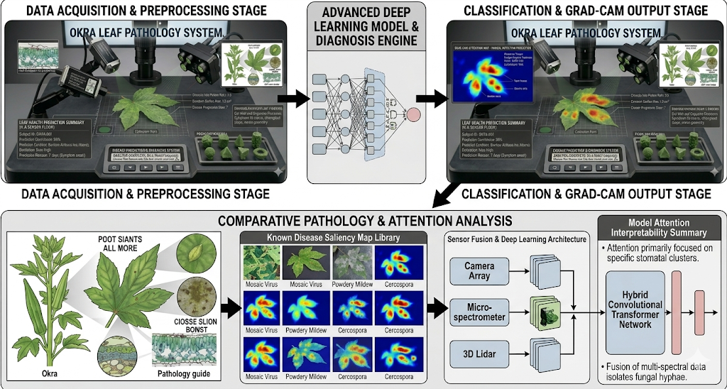
Fig1. Working Block diagram of the Proposed System

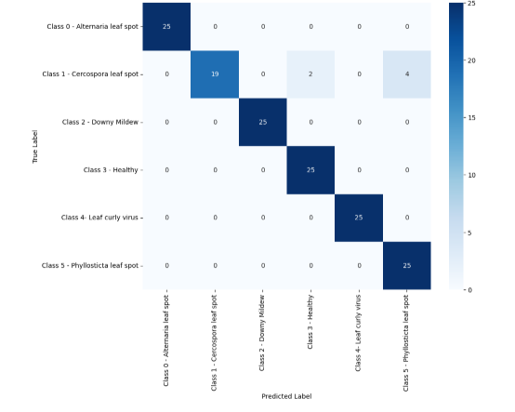 Fig2. Hybrid Model Confusion matrix
The system uses a hybrid deep learning framework to identify and classify okra leaf diseases. The combination of ResNet50, ResNet101, CBAM, and Grad-CAM is applied for the diagnosis of plant diseases. The principle behind the proposed system is more helpful to farmers. A farmer just captures an image of an affected leaf with the mobile camera and directly uploads it on a web-based application. In the future it can also process locally with lightweight computing devices. Local computing is useful in rural farming areas where internet access is very bad or unavailable. Once the image is uploaded, visual aspects such as color variations, textures, the shape of lesions, and the diseased portions on a leaf are analyzed. The model is trained to classify images into six kinds of categories: downy mildew, Alternaria leaf spot, Phyllosticta leaf spot, Cercospora leaf spot, leaf curl virus, and healthy leaf. It carries out more classification than the conventional approach. Here two deep networks are used together as dual backbone networks for feature extraction in which ResNet50 and ResNet101 together give moderate and deeper features in the form of features of leaves. Certain diseases show visible symptoms, while others just have few small changes in color on the leaf that could be overlooked. With this system we are able to pinpoint those points with ease. CBAM is also used along with the system to increase the strength of the feature learning with greater emphasis on the areas that are infected and damaged. CBAM learns to give less importance to irrelevant background information that is present, such as shadows on the plant and also in varied lighting and conditions. The farmers get greater benefits while working under diverse field conditions. Grad-CAM, a method of localization, is used to illustrate the location of the affected region for the farmer, which is one of the very important parts. A highlighting of the specific disease-affected region on the leaf, accompanied by the score, is more beneficial than a simple name display of the disease. The system provides an appropriate and reliable solution for disease diagnosis in the leaf of an okra plant. The combination of deep feature extraction, attention learning, and explainable AI makes this system suitable for the smart farming application.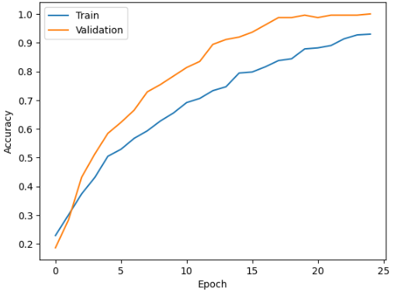
Fig3. Hybrid Model Accuracy
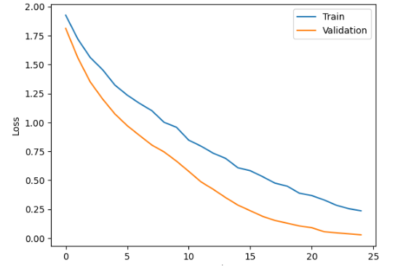
Fig4. Hybrid Model Loss

- COMPARATIVE ANALYSIS OF EXIXTING PLATFORMS AND PROPOSED SYSTEMS

FEAUTURE | TRADITIONAL METHODS | EXISTING DEEP LEARNING APPROACHES | PROPOSED FRAMEWORK (RESNET50 + RESNET101 WITH CBAM & GRAD-CAM)
SPEED | Gradual | Not Measurable | High-Speed And Real Time
ACCURACY | Minimum to Medium | High | High And Robust:
INTERPRETABILITY | High but Subjective | Black Box | Simple
DEPLOYMENT | Not Practical | Difficult | Seamless Edge Deployment:
COST | Expensive | Equipment Cost is High | Minimal
Table 1. Comparison table

To emphasize the efficacy of the newly presented scheme, the new scheme introduces an extremely quick and automatic deep learning setup targeted to operate in real-time that completely overcomes the drawbacks of older and existing methods regarding the disease identification on the okra leaves. The new scheme facilitates easy setup on economical android phones and edge devices, overcoming older methods which required slow human evaluation and expensive and complicated systems. Moreover, despite most deep learning methods in practice being black-box, cost-intensive, difficult to deploy and requiring significant computing power. The proposed new setup (ResNet50 + ResNet101) and attention module (CBAM), Importantly, replacing complex or absent explainability by a user-friendly and clear heat-map illustration of the affected regions via direct incorporation of Grad-CAM into the framework to obtain excellent explainability and user-trust in the real farming system.

TARGET DISEASE CLASS | METRIC | RESNET50 | RESNET101 | HYBRID MODEL
CLASS 0 - ALTERNARIA LEAF SPOT | P | 1.00 | 1.00 | 1.00
CLASS 0 - ALTERNARIA LEAF SPOT | R | 1.00 | 1.00 | 1.00
CLASS 0 - ALTERNARIA LEAF SPOT | FS | 1.00 | 1.00 | 1.00
CLASS 1 - CERCOSPORA LEAF SPOT | P | 1.00 | 0.85 | 0.90
CLASS 1 - CERCOSPORA LEAF SPOT | R | 0.76 | 0.95 | 0.98
CLASS 1 - CERCOSPORA LEAF SPOT | FS | 0.86 | 0.90 | 0.94
CLASS 2 - DOWNY MILDEW | P | 1.00 | 0.92 | 0.96
CLASS 2 - DOWNY MILDEW | R | 1.00 | 096 | 1.00
CLASS 2 - DOWNY MILDEW | FS | 1.00 | 0.94 | 0.98
CLASS 3 - HEALTHY | P | 0.93 | 1.00 | 1.00
CLASS 3 - HEALTHY | R | 1.00 | 1.00 | 1.00
CLASS 3 - HEALTHY | FS | 0.96 | 1.00 | 1.00
CLASS 4 - LEAF CURLY VIRUS | P | 1.00 | 1.00 | 1.00
CLASS 4 - LEAF CURLY VIRUS | R | 1.00 | 1.00 | 1.00
CLASS 4 - LEAF CURLY VIRUS | FS | 1.00 | 1.00 | 1.00
CLASS 5 - PHYLLOSTICTA LEAF SPOT | P | 0.86 | 1.00 | 1.00
CLASS 5 - PHYLLOSTICTA LEAF SPOT | R | 1.00 | 1.00 | 1.00
CLASS 5 - PHYLLOSTICTA LEAF SPOT | FS | 0.93 | 1.00 | 1.00
OVERALL ACCURACY |  | 0.96 | 0.97 | 0.98
MACRO AVERAGE |  | 0.96 | 0.97 | 0.98
WEIGHTED AVERAGE |  | 0.96 | 0.97 | 0.98
Tab2. Accuracy, Precision (P), Recall(R), F1-Score (FS) of Traditional and proposed model

RESULT AND DISCUSSION

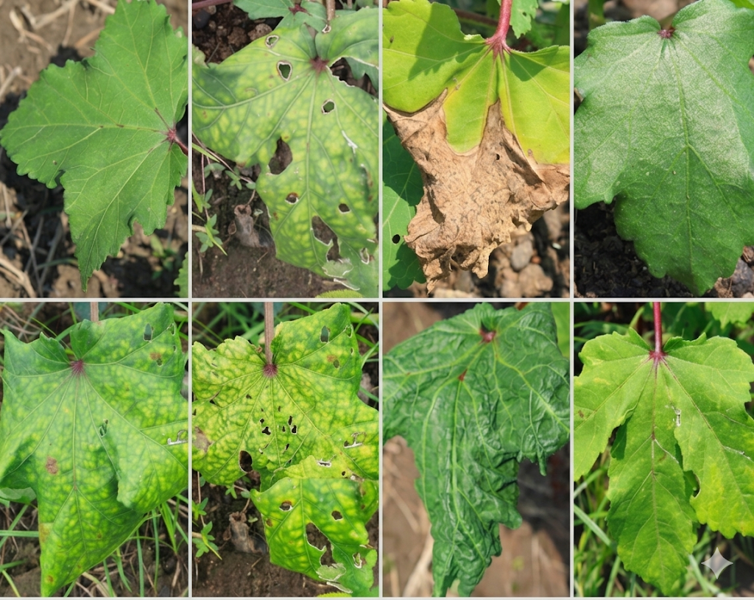
Fig5. Sample images
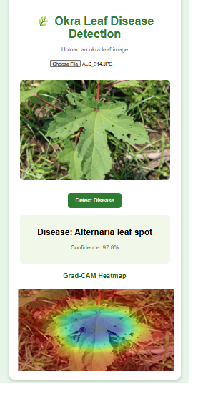
`` Fig6. Hybrid model Output

The user can simply upload a leaf photo of the okra in JPEG or PNG format. The system consults the trained deep learning model and outputs the result as a score and detected disease. This score represents the probability of certainty for this classification. The input image uploaded to the system has been successfully predicted to be Alternaria leaf spot by 97.8%, and the affected area is visualized with the Grad-CAM technique on the image of the okra leaf to help the user find out what the damaged locations of his crops are. The interface has provided a simple and user-friendly method for farmers with little or no computer knowledge. VI. CONCLUSION This proposed framework is developed for okra leaf diseases and spot categories using the fusion of ResNet50, ResNet101, and a CBAM module. The system offered a perfect identification of okra leaf disease, and that was defined earlier. The hybrid model is indeed useful. Compared to standalone CNN backbones, the hybrid model shows better results in classification as well as generalization performance with an accuracy of 98% in the detection of diseases, and with the Grad-CAM module with the proposed system, we achieved more clarification in the visualization by showing clearly the areas that are severely affected. This framework system is portable, user-friendly, and very easy to use for smart farming, which helps to save crops from damage and promotes sustainable agricultural practices.
- FUTURE ENHANCEMENT
Further work on the offline okra leaf disease detection system can include the following: increasing the training set with more diversity of okra leaf images collected in varying light conditions, growth stages, and field contexts to enhance the generalizability of the hybrid model; using incremental learning mechanisms for allowing the model to learn continuously and effectively adapt to new plant diseases and conditions without retraining from the beginning.

- REFERENCES

- Zaichun Yang , Lixiang Sun , Jinsheng Deng, Ailing Cai , Zhihuan Liu, Genhua Liu , Jiang Zhang * , Guoxiong Zhou,* , Yahui Hu, Liujun Li e, “A multi-scale linear cross-modal fusion architecture for tomato leaf disease segmentation”,2026
- Yali Bai, Chenwei Nie, Xun Yu, Mingyue Gou, Shuaibing Liu, Yanqin Zhu, Tiantian Jiang , Xiao Jia, Yadong Liu, Fei Nan, Liming Li, Bedir Tekinerdogan, Yang Song, Qingzhi Liu, Xiuliang Jin, “Comprehensive analysis of hyperspectral features for monitoring canopy maize leaf spot disease”,2024
- Zidi Wu, Ding Peng, Mingfang He, Chaoying He, Yang Hu, EPDNet, “A method for identifying tomato leaf diseases with uneven samples”,2026
- Poonam Ray, Divya Chandran∗,2024, “Spray inoculation and image analysis-based quantification of powdery mildew disease severity on pea leaves”
5. A K M Fazlul Kobir Siam, Prayma Bishshash, Md. Asraful Sharker Nirob, Sajib Bin Mamun, Md Assaduzzaman∗ , Sheak Rashed Haider Noori ,“A comprehensive image dataset for the identification of lemon leaf diseases and computer vision applications”,2025
6. James Daniel Omaye, Emeka Ogbuju, Grace Ataguba, Oluwayemisi Jaiyeoba, Joseph Aneke, Francisca Oladipo ,”Cross-comparative review of Machine learning for plant disease detection: apple, cassava, cotton and potato plants”,2024
7. Sachin Dahiya, Tarun Gulati, Dushyant Gupta, “Performance analysis of deep learning architectures for plant leaves disease detection”,2022
8. Naveena S, Kavitha K, “EnsembleNet model:A hybrid approach for classifying Gossypium Herbaceum leaf diseases using image feature analysis “,2026
9 S.M. Nuruzzaman Nobel, Md All Moon Tasir, Shirin Sultana, Asmaa Soliman Al-Moisheer,, Mohammad Ali Moni ,“An explainable deep learning model for mulberry leaf classification and disease detection,”2026
10. Khang Nguyen Quoc, Lan Le Thi Thu, Luyl-Da Quach¸”A vision-language foundation model for leaf disease identification”, 2026
11. Muhammad Aiman Wafi Nazri, Tajul Rosli Razak , “Towards deployable and explainable deep learning models for paddy leaf disease classification in R: A comparative study of CNN architectures with SHAP and LIME,”2026

