Vehicle Routing Problem in Under Deadlines: A Systematic Literature Review
Syifa Intan Sukmawati¹, Prafajar Suksessanno Muttaqin²
^{1,2} Logistics Engineering Study Program, School of Industrial and System Engineering
Telkom University
Bandung 40257, Indonesia
Syifa.intan96@gmail.com, prafajars@telkomuniversity.ac.id
Surya Michrandi Nasution³ and Reza Rendian Septiawan⁴
^{3,4} Computer Engineering Study Program, School of Electrical Engineering
Telkom University
Bandung 40257, Indonesia
Michrandi@telkomuniversity.ac.id, Zaseptiawan@telkomuniversity.ac.id
Abstract
Transportation is one of the key areas in supply chain management. Emergency vehicles, firefighters, and ambulances are one of the priorities needed in densely populated settlements to reduce casualties from an incident. This study aims to map VRP research by considering under-deadline conditions and provide an overview of current trends and positions for future research. A systematic literature review is necessary to connect studies, investigations, and decision-making. It can be validated with databases that need to be reviewed using a systematic search including research questions, methodology, and specific exclusion and inclusion criteria. Based on the results of the analysis that has been carried out, the results of the most suitable journals were published in Applied Soft Computing, Procedia Computer Science, Computers & Industrial Engineering, and Transportation Research Part E. The most frequently used method is the Exact Algorithm. And eight types of variables are by the existing discussion.
Keywords: Vehicle Routing Problem, Systematic Literature Review, Emergency Vehicle, Firefighters, Ambulance

Introduction
Transportation is one of the key areas of efficiency and effectiveness in supply chain management, and a difficult problem in the field of transportation is the vehicle routing problem (VRP) [1]. Solving transportation problems using this technology can provide appropriate and rapid progress in reducing travel time, reducing congestion, shortening the distance from the origin location to the destination location, etc [2]. Dantzig & Ramser (1959) is a figure who introduced and defined VRP as a problem in scheduling vehicle depots to customers by minimizing the distance of the vehicle's travel. Objectives and model categories about VRP that have been published from 2019 to 2021 with a total 88 journals [3].
Several types of VRP can be categorized based on objectives and constraining factors. Types of VRP based on constraining factors include Multiple Trips Vehicle Routing Problem (MTVRP), Vehicle Routing Problem with Time Windows (VRPTW), Pickup and Delivery Vehicle Routing Problem (PDVRP), Capacities Vehicle Routing Problem (CVRP), VRP with Multiple Products, Multiple Depots Vehicle Routing Problem (MDVRP), Periodic Vehicle Routing Problem, VRP with Heterogeneous Fleet of Vehicles.
EVP or emergency vehicle priority is one of the mobility settlements that gives a green signal to ambulance vehicles and fire trucks [4]. EVP in a settlement is key to the safety and security of both the lives and property of residents. Therefore, the timeliness of handling a case at the scene is an important factor in saving human lives in an urgent situation.
Regulations regarding EVP vehicles or emergency vehicle priorities are regulated in the traffic law in Article 134 of the Road Traffic and Transportation Law (UU LLAJ) which states that 7 types of vehicles get priority on the road, including fire fighting vehicles, ambulance vehicles, vehicles to assist traffic accidents, vehicles of state institution leaders, vehicles of foreign leaders and dignitaries as international guests, funeral escort vehicles, and certain convoy vehicles according to the consideration of the police. Therefore, the discussion that will be the focus of this research regarding the type of priority vehicles are emergency vehicles, fire fighting vehicles, and ambulance vehicles.

Research Method
A systematic literature review is necessary to link studies, investigations, and decision-making prepared and written by " reputable researchers" and " experienced authors" [5]. Systematic literature reviews can be validated with databases that need to be reviewed using systematic searches including focused research questions, appropriate methodology, and specific exclusion and inclusion criteria [6].
To make an analysis, steps are needed in using the systematic literature review method, which is to create a research question, conduct a literature review, select relevant journals, analyze the results of categorizing relevant journals, and make conclusions from the results that have been carried out [7].
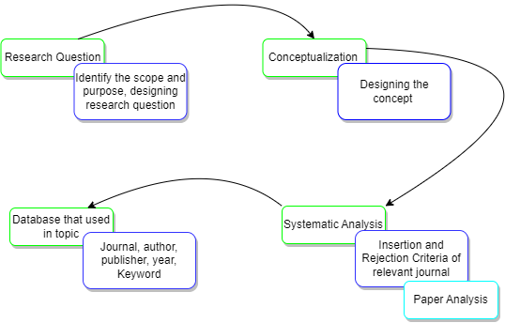
Figure 1. Schematic Review Planning Flow

2.1 Research Questions
Following the Schematic Review Planning Flow that has been displayed in Figure 1. the first step that will be taken is to determine the research question as a formulation of research problems that will be answered based on the research results.
The purpose of this research is to determine and identify the variables, methods, and trends that are most suitable for the topic to be discussed Designing research questions is one of the ways that can be used in identifying variables, methods, and trends that are suitable for the topic to be discussed designing research questions, it must be adjusted to the accuracy of developing research questions. One of the ways that can be used to design research questions is by using the PICOC system to consider the components that are important in the criteria.
Table 1. Summary of PICOC
Population | Route optimization for emergency vehicles such as fire engines and ambulances as well as vehicles needed to evacuate goods and people.
Intervention | Optimizing the best route to minimize emergency vehicle handling time by considering several determinant factors.
Comparison | n/a
Outcomes | The best route in route optimization for emergency vehicles such as firefighters and ambulances as well as vehicles needed in evacuating goods and people using the VRP method.
Context | Studies related to route determination using the VRP method which is used to determine the best route for firefighters and ambulances as well as the vehicles that are needed in evacuating goods and people.
In Table 1. It summarizes the question structure using the PICOC system which has five components that can be considered such as population, intervention, comparison, outcomes, and context. The aim of creating this PICOC system is to make it easier for the author to determine what research questions are suitable for the topic to be discussed. After designing using PICOC, the next step is to determine the research questions.
Table 2. Research Question
$${RQ}_{n}$$ | Research Question (RQ) | Scientific Rational
RQ1 | The most suitable journal with the best route optimization for the emergency vehicle type. | Identify the most suitable journal with the best route optimization for critical vehicle types.
RQ2 | The most frequently used method concerning best route optimization for critical vehicle types. | Identify the trend of the method used by the research journal with the best route optimization for critical vehicle types.
RQ3 | Most variables are often used on the topic of best route optimization for emergency vehicle types. | Identify variables that are often used on the topic of best route optimization for critical vehicle types.
In Table 2. Explain the research questions that are needed and the appropriate way to solve these questions.

2.2 Conceptualization
In the conceptualization section, the strategy, and steps for searching the most relevant journals to the topic are described. This search strategy aims to identify journal articles and summarize them that are only related to route optimization problems in priority vehicles, especially ambulance, and fire fighting vehicles and vehicles used to assist in handling an emergency event.
The discussion will focus on the variables and methods discussed in the journal. The search is performed using the Boolean AND system in the sentence “Vehicle” AND “Routing” AND “Problem” AND “In Emergency” AND “Vehicle” or can use “Vehicle” AND “Routing” AND “Problem” AND “In Firefighter” or can also use “Vehicle” AND “Routing” AND “Problem” AND “In Ambulance”. The following is an illustration of the main study search strategy.
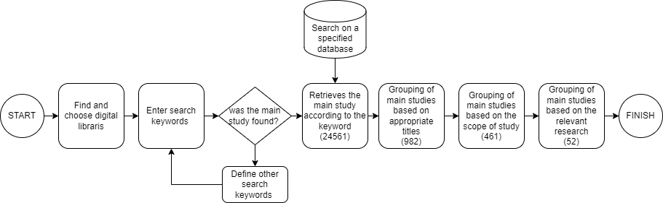
Figure 2. Main Study Search Strategy
In Figure 2. Explains the flow of the series of concepts that will be implemented. Starting from searching the journal platform in the digital librarian, determining the online database platform, and which keywords will be used to group journals that have the main study discussion by relevant research.
The strategy in making the main study search concept aims to facilitate the categorization of relevant journals. This is because the scope of journals that correspond to the relevant system will be narrower.

Systematic Analysis
This research uses Mendeley software as a tool to assist in storing and organizing references that will be used during this research until achieving research results. The final list of the first stage of the main study search was 52 main studies using the insertion and rejection criteria.
The determination of accepted and unaccepted criteria is adjusted to the criteria used. The first step that can be done is to search for journals needed during the research process by focusing on the criteria of journals that have been published from 2013 to 2023 and the acceptance string that will be retrieved from the title, abstract, and content of the research discussed in online databases such as data science or Scopus.
The next step is to determine what criteria are acceptable which are the types of attributes that are by the topic discussed and are important to be taken, while the unacceptable criteria have attributes that are incompatible with the discussion and must be excluded. The inclusion and rejection criteria will be explained in Table 3. as follows.
Table 3. Insertion & Rejection Criteria
Insertion Criteria | Research or studies that address route optimization for emergency vehicles, firefighters, and ambulances.
Insertion Criteria | For research and studies that have conference and journal versions.
Insertion Criteria | Duplicate publications of the same research and study, only the most complete and recent publications will be included.
Insertion Criteria | For research and studies published between 2013 and 2023.
Rejection Criteria | For research and studies that discuss other than route optimization.
Rejection Criteria | For research and journals in languages other than English.

Determining the criteria for acceptable and unacceptable journal categories is aimed at categorizing specifically from journal searches that are only initiated by using the Boolean AND system in the online database. Another purpose of using the determination of acceptable and unacceptable criteria on relevant journals is to narrow down the search for relevant journals so that it can be more specific to the topic of the problem.
By applying the criteria of acceptable and unacceptable journals to the relevant search system, the categorization of the final list of major studies obtained from the last 10 years from 2013 to 2023 can be seen in Figure 3 below.
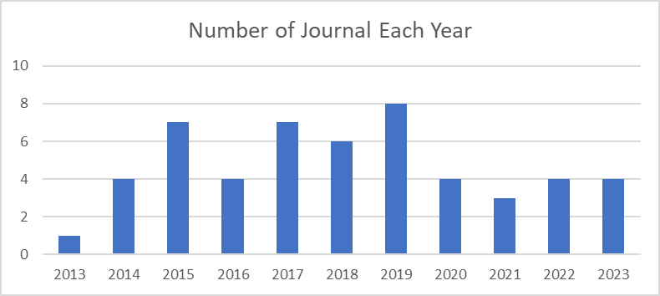
Figure 3. Number of Journals in the Last 10 Years
The results are shown in Figure 3. It shows that the number of journals that have been published in the last 10 years has a different frequency each year, with the highest number of journals that have been uploaded in 2019 with a total of 8 journals related to the topic discussed. However, the journals listed each year by the relevant system have experienced ups and downs.

Database
The database in this study uses four types of databases such as Emerald, IEEE Express, Taylor & Francis, and ScienceDirect which are based on online databases. The amount of data obtained from the four types of databases that will be used based on the type of keywords from the search for journals which are divided into three categories, including vehicle route problems in emergency vehicles, fire fighting vehicles, and ambulance vehicles shown in Table 4. with a final total of 52 journals.
Table 4. The final main study journal besides one relevant research
Keyword | Emerald | IEEE | Taylor&Francis | ScienceDirect
Vehicle Routing Problem in Emergency Vehicle | 3 | 7 | 3 | 17
Vehicle Routing Problem in Firefighter | 1 | 2 | 0 | 6
Vehicle Routing Problem in Ambulance | 1 | 2 | 1 | 9
TOTAL | 5 | 11 | 4 | 32
The results are presented in Table 4. showing that the number of journals that match the relevant system from each category is different. The largest number of relevant journals is in the keyword vehicle route problems in emergency vehicles, also the online database has the most relevant journals in the ScienceDirect database which has the largest database results, namely 32 journals. The relevant journals have different types of journal publications, the top eight journal publications are shown in Figure 4.
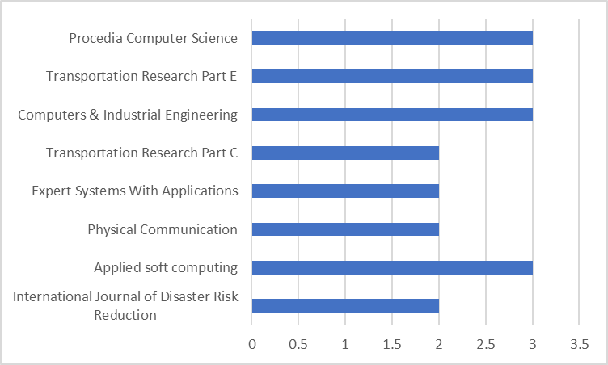
Figure 4. TOP 8 categories of publications of VRP
From the results in Figure 4. Four types of publication categories have the highest number of journals. Based on the category of the number of journals contained in each online database used and the number of journal publication types, the results of the database used can also determine the number of citations contained in each related journal. The top five citations based on the title are shown in Table 5.
Table 5. TOP 5 Citation of Tittle Journals Relevant
Title | Citation | Country | University
Greedy-search-based multi-objective genetic algorithm for emergency logistics scheduling | 151 | Taiwan | National Sun Yat-sen University dan I-Shou University
A stochastic programming approach for flood emergency logistics | 94 | Chile | Universidad Diego Portales
A simulation-optimization framework for ambulance deployment and relocation problems | 74 | China | Shanghai University
Emergency transportation network design problem: Identification and evaluation of disaster response routes | 50 | Iran | Iran University of Science and Technology dan Bu-Ali Sina University
Optimization of vehicle routing problem for emergency cold chain logistics based on minimum loss | 46 | China | Beijing Union University
From the top results in Table 5. The highest number of citations from 2013 to 2023 amounted to 151 [8] from Taiwan. The data was taken on November 28, 2023, from 1:00 PM to 6:00 PM GMT+7.

RESULT AND DISCUSSION

5.1 Objective Function
The objective function is one of the steps in making scientific papers that must be considered after knowing what problems will be analyzed and provide a solution to these problems. The categories of optimization algorithm methods that are a reference for the categorization of methods from relevant systems are Exact, Heuristic, Metaheuristic, Simulation, and Combination methods [9]. The percentage results of journal categorization based on the objective function of the relevant journals show that the objective function category "Minimum Travel Time" has a result of 37%, which is the largest category among other types of categories.

5.2 Distribution of Method
The method that will be used by a writer to find a solution to the existing problem objectives, is very necessary to determine which is by the problem objectives. An optimization algorithm is a numerical algorithm that can be used as a problem solver by involving the value of a scale or vector that aims to minimize or maximize the objective function of the problem [9].
Problems related to vehicle routes in emergency conditions have been addressed in many previous studies. Various approaches have been taken to find the optimal solution. An exact algorithm is a type of algorithm that can find the optimal solution to any problem. It is known as an exact algorithm. For all those problems, where it is not possible to find the most optimal solution, approximation algorithms are used. An approximate algorithm is a type of algorithm that finds a result as the average result of sub-results for a problem. Examples of exact algorithms used in related research are mixed integer linear programming and dynamic programming.
The second type of algorithm is a heuristic algorithm which is a method or rule of thumb used to find a good or adequate solution in a reasonable time, although it does not guarantee an optimal solution. The characteristics of heuristic algorithms do not guarantee the best solution but rather focus on providing a good enough solution in a limited time. Examples of heuristic algorithms used in related research are nearest neighbor and Dijkstra.
The third type of algorithm is metaheuristic which is a general approach to designing heuristic algorithms that can be applied to various optimization problems without having to be specifically adapted for each problem. The characteristics of metaheuristic algorithms are more general and flexible than conventional heuristics because they can be adapted to various optimization problems. It is usually iterative, improving the solution gradually through a series of search steps. Examples of heuristic algorithms used in related research are genetic algorithms and tabu search.
The next type of solution is simulation which can be used when there are limitations to solving problems in mathematical models. Another approach used can be a combination that integrates optimization and simulation models in solving route problems in emergency conditions. The distribution of methods used in solving route problems in emergency conditions is shown in Figure 6.
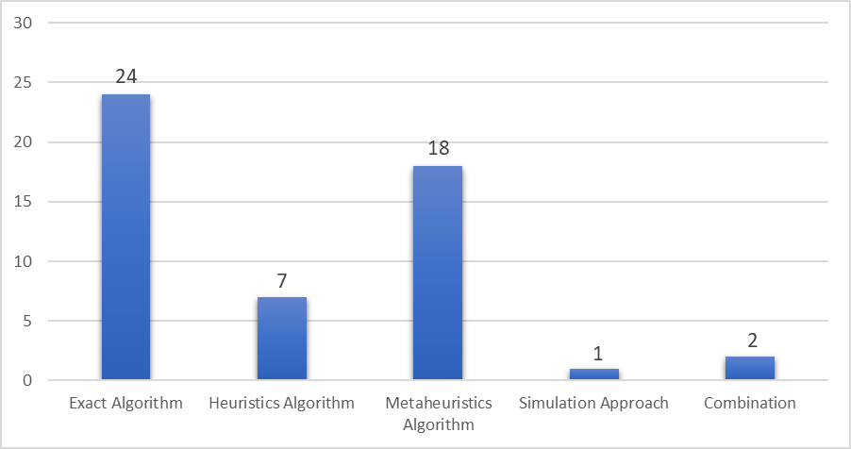
Figure 5. Distribution of the most frequently used methods

5.3 Categorization
After determining the most categories of objective functions of relevant journals, the next step is to determine the journals based on the categories that have been prepared. These categories include Point of Origin, Type of Depot, Vehicle Number, Geographic, Vehicle, Travel Time, Transportation, and Data Type. The categories can be shown in Table 6. as follows.
Table 1. Author and categories of relevant system
Author | PO |  | TD |  | VN |  | GEO |  |  | VH |  | AP |  |  | TP |  |  | DU
Author | SO | MO | SD | MD | EV | Up to | UR | RU | UN | SV | HV | DE | ST | UN | TTD | DD | VD |  |  | RD | Mix
[10] |  | P |  | P |  | P |  | P |  | P |  |  | P |  | P |  |  |  |  |  | P
[11] |  | P |  | P | P |  | P |  |  | P |  |  | P |  | P | P |  |  |  | P
[12] | P |  |  | P |  | P | P |  |  |  | P | P |  |  |  | P |  |  |  |  | P
[13] | P |  |  | P |  | P |  |  | P | P |  |  | P |  | P |  | P |  |  |  | P
[14] |  | P |  | P |  | P | P |  |  | P |  |  | P |  | P |  |  |  |  | P
[15] | P |  |  | P |  | P |  | P |  | P |  |  | P |  |  | P |  |  |  | P
[16] | P |  |  | P | P |  |  |  | P | P |  |  |  | P |  | P |  |  |  |  | P
[17] |  | P |  | P |  | P | P |  |  |  | P |  | P |  |  |  | P |  |  | P
[18] | P |  |  | P |  | P |  |  | P | P |  |  | P |  | P | P |  |  |  |  | P
[19] |  | P |  | P | P |  |  |  | P |  | P |  | P |  | P | P |  |  |  |  | P
[20] |  | P |  | P |  | P | P |  |  |  | P |  | P |  | P | P |  |  |  |  | P
[21] |  | P |  | P | P |  | P |  |  | P |  |  | P |  |  | P |  |  |  |  | P
[22] | P |  |  | P | P |  | P |  |  | P |  |  | P |  |  | P |  |  |  |  | P
[23] |  | P |  | P |  | P | P |  |  |  | P |  | P |  | P |  |  |  |  | P
[24] | P |  |  | P | P |  | P |  |  | P |  |  | P |  |  | P |  |  |  |  | P
[25] | P |  |  | P | P |  | P |  |  | P |  | P |  |  |  | P |  |  |  |  | P
[26] | P |  | P |  | P |  |  |  | P | P |  | P |  |  |  | P |  |  |  | P
[27] |  | P |  | P | P | P | P |  |  | P |  |  | P |  | P | P |  |  |  |  | P
[28] |  | P |  | P | P |  | P |  |  | P |  |  | P |  | P |  |  |  |  | P
[29] | P |  |  | P | P |  | P | P |  | P |  | P |  |  |  | P |  |  |  | P
[30] |  | P |  | P |  | P | P |  |  | P |  |  | P |  | P | P |  |  |  |  | P
[31] | P |  |  | P | P |  | P | P |  | P |  | P |  |  |  | P |  |  |  | P
[32] | P |  |  | P | P |  | P |  |  | P |  |  | P |  | P |  |  |  |  |  | P
[33] | P |  |  | P | P |  | P |  |  | P |  | P |  |  | P |  |  |  |  |  | P
[34] | P |  | P |  |  | P |  |  | P | P |  |  | P |  | P |  |  |  |  |  | P
[8] |  | P |  | P | P |  |  |  | P |  | P | P |  |  |  | P | P |  |  | P
[35] |  | P |  | P |  | P | P |  |  |  | P |  | P |  | P |  |  |  |  | P
[36] |  | P |  | P |  | P | P | P |  | P |  |  | P |  | P | P |  |  |  |  | P
[37] |  | P |  | P |  | P | P |  |  | P |  |  | P |  |  | P |  |  |  | P
[38] |  | P |  | P | P |  | P | P |  |  | P | P | P |  | P |  |  |  |  |  | P
[39] | P |  |  | P | P |  | P |  |  | P |  | P |  |  | P |  |  |  |  |  | P
[40] |  | P |  | P |  | P | P | P |  | P |  |  | P |  | P |  | P |  |  |  | P
[41] | P |  |  | P | P |  |  |  | P | P |  |  | P |  | P |  |  |  |  | P
[42] | P |  |  | P |  | P | P |  |  | P |  |  | P |  | P |  |  |  |  |  | P
[43] |  | P |  | P |  | P |  | P |  | P |  |  | P |  |  |  | P |  |  |  | P
[44] |  | P |  | P |  | P |  | P |  | P |  |  | P |  | P |  | P |  |  |  | P
[45] |  | P |  | P | P |  |  | P |  | P |  |  | P |  | P | P |  |  |  |  | P
[46] |  | P |  | P | P |  |  | P |  |  | P |  | P |  |  |  | P |  |  |  | P
[47] | P |  | P |  | P |  | P |  |  | P |  | P |  |  |  | P |  |  |  | P
[48] | P |  | P |  | P |  | P |  |  | P |  |  | P |  | P |  |  |  |  |  | P
[49] |  | P |  | P | P |  |  |  | P | P |  |  | P |  | P |  |  |  |  |  | P
[50] |  | P |  | P |  | P | P |  |  |  | P |  | P |  | P |  |  |  |  | P
[51] |  | P | P |  | P |  | P | P |  | P |  |  | P |  | P |  |  |  |  |  | P
[52] | P |  |  | P | P |  |  |  | P | P |  | P |  |  |  | P |  |  |  | P
[53] | P |  |  | P | P |  |  |  | P | P |  |  | P |  | P |  |  |  |  | P
[54] |  | P | P |  | P |  | P |  |  | P |  | P |  |  |  | P |  |  |  |  | P
[55] | P |  |  | P | P |  | P |  |  | P |  |  | P |  | P |  | P |  |  |  | P
[56] | P |  |  | P | P |  | P | P |  | P |  |  | P |  | P |  |  |  |  |  | P
[57] | P |  |  | P |  | P | P |  |  |  | P |  | P |  | P |  |  |  |  | P
[58] |  | P |  | P | P |  | P |  |  | P |  |  | P |  | P |  |  |  |  |  | P
[59] |  | P |  | P |  | P | P |  |  |  | P |  | P |  | P |  |  |  |  |  | P
TOTAL | 24 | 27 | 6 | 45 | 30 | 22 | 34 | 13 | 11 | 39 | 12 | 12 | 39 | 1 | 33 | 23 | 8 |  |  | 18 | 33
Annotation:
- Point of Origin (PO), Type of Depot (TD), Vehicle Number (VN), Geographic (GEO), Vehicle (VH), Approach Method (AP), Transportation (TP), and Data Used (DU).
- Single Origin (SO), Multiple Origin (MO), Multiple Depot (MD), Exactly Vehicle (EV), Up to Vehicle (Up To), Urban (UR), Rural (RU), Similar Vehicle (SV), Heterogenous Vehicle (HV), Deterministic (DE), Stochastic (ST), Unknown (UN), Travel Time-Dependent (TTD), Distance Dependent (DD), Vehicle Dependent (VD), Real-World Data (RD) and Synthetic Data (SC).

5.1.1 Point of Origin (PO) and Type of Depot (TD)
Point of Origin in the context of a vehicle emergency is a point from which an incident occurs that can be used by emergency responders to get to the scene of the incident [60]. Point of Origin is divided into 2 types of single and multiple characteristics [3]. The type of Depot in the context of a vehicle emergency is the destination point of an incident location, such as evacuation sites, hospitals, etc. Depots can also be defined as emergency vehicle locations for storage and maintenance. Depot types are divided into 2 types, single and multiple [3].

5.1.2 Vehicle Number (VN) and Data Used ( DU)
Vehicle Number is divided into 2 types, Exact vehicle and Up to Vehicle [3]. Exact means that the vehicle with the load must maximize the vehicle capacity and the route taken must go through the starting point to the end, while Up to the Vehicle, the vehicle with the load does not have to maximize the vehicle capacity and the route taken does not have to be one way. Data Used is a categorization section that can be used as a problem analysis by adjusting to the usage of the data. Used data is divided into 2 types such as synthetic, real data, and data that combines 2 types of data [3].

5.1.3 Geographic (GEO) and Vehicle (VH)
Geographic is divided into 2 types: urban and rural [3], urban means a settled area (big city) while rural is a village area. The context of this vehicle is the type of vehicle that will be used in handling an incident. Vehicles are divided into 2 types: similar and heterogeneous [3].

5.1.4 Approach Method (AP) and Transportation (TP)
The approach Method is one of the methods used to perform an approach in analysis and modelling. Approach Method is divided into 3 types Deterministic, stochastic, and Unknown which means it is not clear what approach should be used [3]. Transportation in this context can be categorized into 3 types, which are Travel Time-Dependent, distance-dependent, and vehicle-dependent [3] which have their meaning according to the parameters used in the journal discussed.

CONCLUSION
This article presents a systematic literature review on the Vehicle Routing Problem under Deadline. This study aims to determine the research GAP and research opportunities that can be used for further research. The analysis of the results of the systematic literature review is to determine which types of journals are suitable for problems in emergency vehicles that use the most suitable methods and variables for solving these problems.
Based on the systematic literature review stage, we obtained 52 journals on the main study discussion which then obtained answers to research questions based on the results of the analysis that had been carried out, including:
- The journals that are most suitable for the main topic of the problem in the period of 2013 to 2023 are in Figure 8. The journals are mostly obtained in four publication locations which are Applied Soft Computing, Procedia Computer Science, Computers & Industrial Engineering, and Transportation Research Part E.
- The method most often used in solving the problem and the objective function can be seen in Figure 6. namely in the type of Exact Algorithm.
- The most frequently used variables in the process of solving a problem can be seen in Table 6. Based on the category of relevant systems, namely Multiple Origin, Multiple Depots, Exact Vehicle, Geographical in Urban, Similar Vehicle, Using Stochastic, Travel Time-Dependent, mixed usage of real and synthetic data.

Acknowledgments
This research was conducted in collaboration between Logistics Engineering, School of Industrial and System Engineering, and Computer Engineering and School of Electrical Engineering.

Funding
This work is funded by The Ministry of Education, Culture, Research, and Technology, Republic of Indonesia (Kementerian Pendidikan, Kebudayaan, Riset, dan Teknologi; Kemdikbudristek) via DRTPM 2023.

References
[1] M. Kumari, P. K. De, K. Chaudhuri, and P. Narang, “Utilizing a hybrid metaheuristic algorithm to solve capacitated vehicle routing problem,” Results in Control and Optimization, vol. 13, Dec. 2023, doi: 10.1016/j.rico.2023.100292.
[2] Y. A. Al-Khassawneh, “A Review of Artificial Intelligence in Security and Privacy: Research Advances, Applications, Opportunities, and Challenges,” Indonesian Journal of Science and Technology, vol. 8, no. 1, pp. 79–96, 2023, doi: 10.17509/ijost.v8i1.52709.
[3] S. Y. Tan and W. C. Yeh, “The vehicle routing problem: State‐of‐the‐art classification and review,” Applied Sciences (Switzerland), vol. 11, no. 21. MDPI, Nov. 01, 2021. doi: 10.3390/app112110295.
[4] P. Rosayyan, J. Paul, S. Subramaniam, and S. I. Ganesan, “An optimal control strategy for emergency vehicle priority system in smart cities using edge computing and IOT sensors,” Measurement: Sensors, vol. 26, Apr. 2023, doi: 10.1016/j.measen.2023.100697.
[5] M. Zibaei, “What is the Systematic Review and Who Does Write it?,” Int J Enteric Pathog, vol. 6, no. 4, pp. 83–83, Nov. 2018, doi: 10.15171/ijep.2018.22.
[6] V. Smith, D. Devane, C. M. Begley, and M. Clarke, “Methodology in conducting a systematic review of systematic reviews of healthcare interventions,” BMC Med Res Methodol, vol. 11, 2011, doi: 10.1186/1471-2288-11-15.
[7] S. Luckyardi, R. Jurriyati, D. Disman, and P. D. Dirgantari, “A Systematic Review of the IoT in Smart University: Model and Contribution,” Indonesian Journal of Science and Technology, vol. 7, no. 3. Universitas Pendidikan Indonesia, pp. 529–550, 2022. doi: 10.17509/ijost.v7i3.51476.
[8] F. S. Chang, J. S. Wu, C. N. Lee, and H. C. Shen, “Greedy-search-based multi-objective genetic algorithm for emergency logistics scheduling,” Expert Syst Appl, vol. 41, no. 6, pp. 2947–2956, May 2014, doi: 10.1016/j.eswa.2013.10.026.
[9] Suyanto, algoritma optimasi : deterministik atau probabilistik, Pertama. Yogyakarta: Graha Ilmu, 2010.
[10] J. Liu and K. Xie, “Emergency materials transportation model in disasters based on dynamic programming and ant colony optimization,” Kybernetes, vol. 46, no. 4, pp. 656–671, 2017, doi: 10.1108/K-02-2016-0028.
[11] M. Babaei, A. Shariat-Mohaymany, N. Nikoo, and A. R. Ghaffari, “A multi-objective emergency network design problem to carry out disaster relief operations in developing countries: A case study of Tehran, Iran,” Journal of Humanitarian Logistics and Supply Chain Management, vol. 9, no. 2, pp. 250–269, Oct. 2019, doi: 10.1108/JHLSCM-12-2018-0081.
[12] J. D. Hong, K. Y. Jeong, and K. Feng, “Emergency relief supply chain design and trade-off analysis,” Journal of Humanitarian Logistics and Supply Chain Management, vol. 5, no. 2, pp. 162–187, Aug. 2015, doi: 10.1108/JHLSCM-05-2014-0019.
[13] M. Chen, “Improved Genetic Algorithm for Emergency Logistics Distribution Vehicle Routing Problems *,” China, 2014.
[14] N. Rathore, P. K. Jain, and M. Parida, “A ROUTING MODEL FOR EMERGENCY VEHICLES USING THE REAL TIME TRAFFIC DATA,” in 2018 IEEE International Conference on Service Operations and Logistics, and Informatics (SOLI), IEEE, Jul. 2018, pp. 175–179. doi: 10.1109/SOLI.2018.8476771.
[15] H. Mizuno and S. Takahashi, “Goods sharing problems for emergency supply,” in Proceedings - 2016 5th IIAI International Congress on Advanced Applied Informatics, IIAI-AAI 2016, Institute of Electrical and Electronics Engineers Inc., Aug. 2016, pp. 1168–1173. doi: 10.1109/IIAI-AAI.2016.241.
[16] Y. He, J. Wen, and M. Huang, “Study on emergency relief VRP based on clustering and PSO,” in Proceedings - 2015 11th International Conference on Computational Intelligence and Security, CIS 2015, Institute of Electrical and Electronics Engineers Inc., Feb. 2016, pp. 43–47. doi: 10.1109/CIS.2015.19.
[17] L. Xu, Z. Wang, X. Chen, and Z. Lin, “Multi-Parking Lot and Shelter Heterogeneous Vehicle Routing Problem With Split Pickup Under Emergencies,” IEEE Access, vol. 10, pp. 36073–36090, 2022, doi: 10.1109/ACCESS.2022.3163715.
[18] X. Yang, Y. Jiang, Y. Zhang, and Z. Liu, “Vehicle type and route selection for emergency logistic management under road damage,” in 2015 IEEE International Conference on Service Operations And Logistics, And Informatics (SOLI), IEEE, Nov. 2015, pp. 100–105. doi: 10.1109/SOLI.2015.7367600.
[19] F. Hu, W. Bai, and C. Tian, “Two-Level Dispatch System of Emergency Supplies with Multiple Objective Functions Using Genetic Algorithms,” in Proceedings - 2015 6th International Conference on Intelligent Systems Design and Engineering Applications, ISDEA 2015, Institute of Electrical and Electronics Engineers Inc., Apr. 2016, pp. 906–911. doi: 10.1109/ISDEA.2015.228.
[20] H. Xia et al., “Emergency medical supplies scheduling during public health emergencies: algorithm design based on AI techniques,” Int J Prod Res, 2023, doi: 10.1080/00207543.2023.2267680.
[21] L. Bu, F. Wang, X. Zhou, and C. Yin, “Managed gating control strategy for emergency evacuation,” Transportmetrica A: Transport Science, vol. 15, no. 2, pp. 963–992, Nov. 2019, doi: 10.1080/23249935.2018.1552336.
[22] D. Liu and S. Ji, “Research on efficient online planning of emergency logistics path based on double-layer ant colony optimization algorithm,” International Journal of Computers and Applications, vol. 41, no. 5, pp. 400–406, Sep. 2019, doi: 10.1080/1206212X.2018.1455019.
[23] A. Zahedi, M. Kargari, and A. Husseinzadeh Kashan, “Multi-objective decision-macking model for distribution planning of goods and routing of vehicles in emergency multi-objective decision-making model for distribution planning of goods and routing of vehicles in emergency,” International Journal of Disaster Risk Reduction, vol. 48, Sep. 2020, doi: 10.1016/j.ijdrr.2020.101587.
[24] Q. Zhang and S. Xiong, “Routing optimization of emergency grain distribution vehicles using the immune ant colony optimization algorithm,” Appl Soft Comput, vol. 71, pp. 917–925, Oct. 2018, doi: 10.1016/j.asoc.2018.07.050.
[25] C. Qi and L. Hu, “Optimization of vehicle routing problem for emergency cold chain logistics based on minimum loss,” Physical Communication, vol. 40, Jun. 2020, doi: 10.1016/j.phycom.2020.101085.
[26] N. Giedelmann-L, W. J. Guerrero, and E. L. Solano-Charris, “On the Emergency Water Distribution Problem: Optimizing Vehicle Routing Decisions with Deprivation Costs Considerations,” IFAC-PapersOnLine, vol. 55, no. 10, pp. 3166–3171, 2022, doi: 10.1016/j.ifacol.2022.10.216.
[27] N. Nikoo, M. Babaei, and A. S. Mohaymany, “Emergency transportation network design problem: Identification and evaluation of disaster response routes,” International Journal of Disaster Risk Reduction, vol. 27, pp. 7–20, Mar. 2018, doi: 10.1016/j.ijdrr.2017.07.003.
[28] Y. Wang, S. Peng, and M. Xu, “Emergency logistics network design based on space–time resource configuration,” Knowl Based Syst, vol. 223, Jul. 2021, doi: 10.1016/j.knosys.2021.107041.
[29] Y. Wang, X. Wang, J. Fan, Z. Wang, and L. Zhen, “Emergency logistics network optimization with time window assignment,” Expert Syst Appl, vol. 214, p. 119145, Mar. 2023, doi: 10.1016/j.eswa.2022.119145.
[30] H. Park, D. Waddell, and A. Haghani, “Online optimization with look-ahead for freeway emergency vehicle dispatching considering availability,” Transp Res Part C Emerg Technol, vol. 109, pp. 95–116, Dec. 2019, doi: 10.1016/j.trc.2019.09.016.
[31] Y. Jiang, B. Bian, and Y. Liu, “Integrated multi-item packaging and vehicle routing with split delivery problem for fresh agri-product emergency supply at large-scale epidemic disease context,” Journal of Traffic and Transportation Engineering (English Edition), vol. 8, no. 2, pp. 196–208, Apr. 2021, doi: 10.1016/j.jtte.2020.08.003.
[32] S. Zhao, Y. Wang, Z. Jiang, T. Hu, and F. Chu, “Research on emergency distribution optimization of mobile power for electric vehicle in photovoltaic-energy storage-charging supply chain under the energy blockchain,” Energy Reports, vol. 8, pp. 6815–6825, Nov. 2022, doi: 10.1016/j.egyr.2022.05.010.
[33] G. Musolino, A. Polimeni, C. Rindone, and A. Vitetta, “Travel Time Forecasting and Dynamic Routes Design for Emergency Vehicles,” Procedia Soc Behav Sci, vol. 87, pp. 193–202, Oct. 2013, doi: 10.1016/j.sbspro.2013.10.603.
[34] K. Huang and R. Rafiei, “Equitable last mile distribution in emergency response,” Comput Ind Eng, vol. 127, pp. 887–900, Jan. 2019, doi: 10.1016/j.cie.2018.11.025.
[35] J. Liu, J. Bai, and D. Wu, “Medical supplies scheduling in major public health emergencies,” Transp Res E Logist Transp Rev, vol. 154, Oct. 2021, doi: 10.1016/j.tre.2021.102464.
[36] G. Chai, J. Cao, W. Huang, and J. Guo, “Optimized traffic emergency resource scheduling using time varying rescue route travel time,” Neurocomputing, vol. 275, pp. 1567–1575, Jan. 2018, doi: 10.1016/j.neucom.2017.09.086.
[37] R. A. Garrido, P. Lamas, and F. J. Pino, “A stochastic programming approach for floods emergency logistics,” Transp Res E Logist Transp Rev, vol. 75, pp. 18–31, Mar. 2015, doi: 10.1016/j.tre.2014.12.002.
[38] S. Yan, C. K. Lin, and S. Y. Chen, “Logistical support scheduling under stochastic travel times given an emergency repair work schedule,” Comput Ind Eng, vol. 67, no. 1, pp. 20–35, 2014, doi: 10.1016/j.cie.2013.10.007.
[39] M. L. Brachman, R. Church, B. Adams, and D. Bassett, “Wayfinding during a wildfire evacuation,” Disaster Prevention and Management: An International Journal, vol. 29, no. 3, pp. 249–265, Apr. 2020, doi: 10.1108/DPM-07-2019-0216.
[40] S. Shahparvari and B. Abbasi, “Robust stochastic vehicle routing and scheduling for bushfire emergency evacuation: An Australian case study,” Transp Res Part A Policy Pract, vol. 104, pp. 32–49, Oct. 2017, doi: 10.1016/j.tra.2017.04.036.
[41] F. Dubois, P. Renaud-Goud, and P. Stolf, “Capacitated Vehicle Routing Problem under Deadlines,” in 2019 International Conference on Information and Communication Technologies for Disaster Management (ICT-DM), IEEE, Dec. 2019, pp. 1–8. doi: 10.1109/ICT-DM47966.2019.9033000.
[42] V. Krasko and S. Rebennack, “Two-stage stochastic mixed-integer nonlinear programming model for post-wildfire debris flow hazard management: Mitigation and emergency evacuation,” Eur J Oper Res, vol. 263, no. 1, pp. 265–282, Nov. 2017, doi: 10.1016/j.ejor.2017.05.004.
[43] S. Shahparvari, B. Abbasi, P. Chhetri, and A. Abareshi, “Fleet routing and scheduling in bushfire emergency evacuation: A regional case study of the Black Saturday bushfires in Australia,” Transp Res D Transp Environ, vol. 67, pp. 703–722, Feb. 2019, doi: 10.1016/j.trd.2016.11.015.
[44] S. Shahparvari, B. Abbasi, and P. Chhetri, “Possibilistic scheduling routing for short-notice bushfire emergency evacuation under uncertainties: An Australian case study,” Omega (United Kingdom), vol. 72, pp. 96–117, Oct. 2017, doi: 10.1016/j.omega.2016.11.007.
[45] B. Bodaghi, E. Palaneeswaran, S. Shahparvari, and M. Mohammadi, “Probabilistic allocation and scheduling of multiple resources for emergency operations; a Victorian bushfire case study,” Comput Environ Urban Syst, vol. 81, May 2020, doi: 10.1016/j.compenvurbsys.2020.101479.
[46] S. Shahparvari, P. Chhetri, B. Abbasi, and A. Abareshi, “Enhancing emergency evacuation response of late evacuees: Revisiting the case of Australian Black Saturday bushfire,” Transp Res E Logist Transp Rev, vol. 93, pp. 148–176, Sep. 2016, doi: 10.1016/j.tre.2016.05.010.
[47] C. R. Kamireddy, Bingisateesh, and B. N. Keshavamurthy, “Efficient routing of 108 ambulances using clustering techniques,” in 2016 IEEE International Conference on Computational Intelligence and Computing Research (ICCIC), IEEE, Dec. 2016, pp. 1–6. doi: 10.1109/ICCIC.2016.7919560.
[48] J. Y. Yu, K. L. Huang, W. Z. Sun, and M. H. M. Ma, “The study of guarding and cruising modes of ambulances for emergency medical service,” Journal of Industrial and Production Engineering, vol. 37, no. 8, pp. 440–450, Nov. 2020, doi: 10.1080/21681015.2020.1840449.
[49] A. El Fallahi and I. Sefrioui, “A linear programming model and memetic algorithm for the Emergency Vehicle Routing,” in 2019 4th World Conference on Complex Systems (WCCS), IEEE, Apr. 2019, pp. 1–5. doi: 10.1109/ICoCS.2019.8930750.
[50] C. Caliskan and K. H. Altintas, “Time, island and ambulance type characteristics of patient transfers from two Turkish islands: Gökçeada and Bozcaada,” International Journal of Emergency Services, vol. 9, no. 1, pp. 47–55, Apr. 2020, doi: 10.1108/IJES-12-2018-0065.
[51] M. Sutherland and R. K. Chakrabortty, “An optimal ambulance routing model using simulation based on patient medical severity,” Healthcare Analytics, vol. 4, Dec. 2023, doi: 10.1016/j.health.2023.100256.
[52] T. Tlili, M. Harzi, and S. Krichen, “Swarm-based approach for solving the ambulance routing problem,” in Procedia Computer Science, Elsevier B.V., 2017, pp. 350–357. doi: 10.1016/j.procs.2017.08.012.
[53] I. ZIDI, M. Al-Omani, and K. Aldhafeeri, “A New Approach Based On the Hybridization of Simulated Annealing Algorithm and Tabu Search to Solve the Static Ambulance Routing Problem,” Procedia Comput Sci, vol. 159, pp. 1216–1228, 2019, doi: 10.1016/j.procs.2019.09.291.
[54] M. Hemici, D. Zouache, B. Brahmi, A. Got, and H. Drias, “A decomposition-based multiobjective evolutionary algorithm using Simulated Annealing for the ambulance dispatching and relocation problem during COVID-19,” Appl Soft Comput, vol. 141, p. 110282, Jul. 2023, doi: 10.1016/j.asoc.2023.110282.
[55] K. Knyazkov, I. Derevitsky, L. Mednikov, and A. Yakovlev, “Evaluation of Dynamic Ambulance Routing for the Transportation of Patients with Acute Coronary Syndrome in Saint-petersburg,” Procedia Comput Sci, vol. 66, pp. 419–428, 2015, doi: 10.1016/j.procs.2015.11.048.
[56] J. A. Acuna, J. L. Zayas-Castro, and H. Charkhgard, “Ambulance allocation optimization model for the overcrowding problem in US emergency departments: A case study in Florida,” Socioecon Plann Sci, vol. 71, Sep. 2020, doi: 10.1016/j.seps.2019.100747.
[57] L. Zhen, K. Wang, H. Hu, and D. Chang, “A simulation optimization framework for ambulance deployment and relocation problems,” Comput Ind Eng, vol. 72, no. 1, pp. 12–23, 2014, doi: 10.1016/j.cie.2014.03.008.
[58] L. Zhen, S. Sheng, Z. Xie, and K. Wang, “Decision rules for ambulance scheduling decision support systems,” Applied Soft Computing Journal, vol. 26, pp. 350–356, 2015, doi: 10.1016/j.asoc.2014.10.001.
[59] G. J. Hannoun and M. Menéndez, “Modular vehicle technology for emergency medical services,” Transp Res Part C Emerg Technol, vol. 140, Jul. 2022, doi: 10.1016/j.trc.2022.103694.
[60] N. Smith, W. Hicks, G. Gorbett, R. Hopkins, and P. Kennedy, “VEHICLE FIRE BURN PATTERN STUDY,” 2010.

